Supplementary Material to

Exploring Zingerone 2-Thiohydantoins as Anticancer Agents against Breast Adenocarcinoma: Cytotoxicity, HSA and DNA Binding, Molecular Docking and ADMET Prediction
Petar B. Stanić,^{1,}* Ana M. Rilak-Simović,¹ Katarina D. Virijević,¹ Jovana M. Muškinja,¹ Nevena S. Jeremić,^{2,3,4} Goran V. Janjić,⁵ Biljana M. Šmit¹
¹ Institute for Information Technologies, University of Kragujevac, Liceja Kneževine Srbije 1A, 34000 Kragujevac, Serbia
² Center of Excellence for Redox Balance Research in Cardiovascular and Metabolic Disorders, Svetozara Markovića 69, 34000 Kragujevac, Serbia
³ Department of Pharmacy, Faculty of Medical Sciences, University of Kragujevac, Svetozara Markovića 69, 34000 Kragujevac, Serbia
⁴ Federal State Autonomous Educational Institution of Higher Education, I.M. Sechenov First Moscow State Medical University of the Ministry of Health of the Russian Federation, 8-2 Trubetskaya str., 119991 Moscow, Russia
⁵ Institute of Chemistry, Technology and Metallurgy, University of Belgrade, Njegoševa 12, 11000 Belgrade, Serbia
*Corresponding author: E-mail: petar.stanic@uni.kg.ac.rs

Spectral data for synthesized compounds
4-(3,4-dimethoxyphenyl)butan-2-one (1a). Yield: 0.887 g (85 %). IR (KBr): 2937m, 2835w, 1713s, 1590m, 1514s, 1464m, 1418m, 1362m, 1257s, 1234s, 1155s, 1139s, 1027s, 803m, 764m cm⁻¹. ¹H NMR (200 MHz, CDCl₃, δ / ppm): 6.69-6.81 (m, 3H, H-6, H-9, H-10), 3.87 (s, 3H, OCH₃), 3.85 (s, 3H, OCH₃), 2.71-2.89 (m, 4H, CH₂-3, CH₂-4), 2.14 (s, 3H, CH₃-1). ¹³C NMR (50 MHz, CDCl₃, δ / ppm): 207.91, 148.81, 147.30, 133.54, 119.97, 111.69, 111.30, 58.82, 55.72, 45.28, 29.97, 29.27.
4-(4-ethoxy-3-methoxyphenyl)butan-2-one (1b). Yield: 1.032 g (93 %). IR (KBr): 3345w, 2979m, 2937w, 1711s, 1588w, 1515s, 1443w, 1424w, 1395w, 1351w, 1249s, 1235s, 1159m, 1140s, 1051m, 1037s, 920w, 874w, 801m, 782w, 546w cm⁻¹. ¹H NMR (200 MHz, CDCl₃, δ / ppm): 6.79 (d, 1H, J = 7.8 Hz, H-9), 6.71 (s, 1H, H-6), 6,69 (d, 1H, J = 8.0 Hz, H-10), 4.06 (q, 2H, J = 7 Hz, CH₂-12), 3.86 (s, 3H, CH₃-11), 2.84 (t, 2H, J = 5.4 Hz, CH₂-3), 2.74 (t, 2H, J = 5.1 Hz,CH₂-4), 2.14 (s, 3H, CH₃-1), 1.44 (t, 3H, J = 7.0 Hz, CH₃-13). ¹³C NMR (50 MHz, CDCl₃, δ / ppm): 208.03, 149.08, 146.51, 133.50, 119.95, 112.78, 111.86, 64.24, 55.76, 45.30, 30.01, 29.28, 14.74.
4-(3-methoxy-4-propoxyphenyl)butan-2-one (1c). Yield: 0.947 g (80 %). IR (KBr): 2963m, 2877m, 1714s, 1589w, 1514s, 1465m, 1419m, 1363m, 1258s, 1231s, 1158m, 1138s, 1036m, 978m, 800m cm⁻¹. ¹H NMR (200 MHz, CDCl₃, δ / ppm): 6.74 (d, 1H, J = 8.0, H-9), 6.71 (s, 1H, H-6), 6.69 (d, 1H, J = 8.2 Hz, H-10), 3.94 (t, 2H, J = 6.8 Hz, CH₂-12), 3.84 (s, 3H, CH₃-11), 2.83 (t, 2H, J = 5.5 Hz, CH₂-3), 2.74 (t, 2H, J = 5.4 Hz, CH₂-4), 2.13 (s, 3H, CH₃-1), 1.84 (sext, 2H, J = 7.2 Hz, CH₂-13), 1.02 (t, 3H, J = 7.5 Hz, CH₃-14). ¹³C NMR (50 MHz, CDCl₃, δ / ppm): 208.01, 149.14, 146.71, 133.44, 119.94, 112.99, 112.02, 70.42, 55.78, 45.24, 29.94, 29.20, 22.34, 10.28.
4-(4-isopropoxy-3-methoxyphenyl)butan-2-one (1d). Yield: 0.926 g (78 %). IR (KBr): 2975m, 2933m, 1714s, 1587w, 1510s, 1465m, 1451m, 1419m, 1369m, 1259s, 1229m, 1157m, 1138m, 1110m, 1035m, 955w, 806w cm⁻¹. ¹H NMR (200 MHz, CDCl₃, δ / ppm): 6.65-6.83 (m, 3H, H-6, H-9, H-10), 4.46 (sept, 1H, J = 6.0 Hz, CH-12), 3.83 (s, 3H, CH₃-11), 2.82 (t, 2H, J = 6.3 Hz, CH₂-3), 2.73 (t, 2H, J = 5.3 Hz, CH₂-4), 2.14 (s, 3H, CH₃-1), 1.33 (d, 6H, J = 6.2 Hz, CH₃-13, CH₃-14). ¹³C NMR (50 MHz, CDCl₃, δ / ppm): 208.24, 150.24, 145.44, 134.02, 119.98, 116.01, 112.28, 71.45, 55.8, 45.31, 30.04, 29.30, 22.02.
4-(4-butoxy-3-methoxyphenyl)butan-2-one (1e). Yield: 1.088 g (87 %). IR (KBr): 2957m, 2935m, 2872w, 1715s, 1589m, 1514s, 1465m, 1419m, 1362m, 1257s, 1233s, 1158s, 1139s, 1034s, 972, 800m cm⁻¹. ¹H NMR (200 MHz, CDCl₃, δ / ppm): 6.79 (d, 1H, J = 7.8 Hz, H-9), 6.71 (s, 1H, H-6), 6.69 (d, 1H, J = 8.0 Hz, H-10), 3.98 (t, 2H, J = 6.8 Hz, CH₂-12), 3.84 (s, 3H, CH₃-11), 2.83 (t, 2H, J = 5.3 Hz, CH₂-3), 2.74 (t, 2H, J = 5.2 Hz, CH₂-4), 2.13 (s, 3H, CH₃-1), 1.81 (quint, 2H, J = 3.6 Hz, CH₂-13), 1.48 (sext, 2H, J = 3.7 Hz, CH₂-14), 0.96 (t, 3H, J = 7.3 Hz, CH₃-15). ¹³C NMR (50 MHz, CDCl₃, δ / ppm): 208.03, 149.17, 146.78, 133.44, 119.96, 112.97, 112.04, 68.65, 55.81, 45.28, 31.14, 29.98, 29.24, 19.07, 13.74.
4-(4-(benzyloxy)-3-methoxyphenyl)butan-2-one (1f). Yield: 1.243 g (87 %). IR (KBr): 2937m, 2870w, 1710s, 1591m, 1516s, 1467m, 1455m, 1419m, 1386m, 1257s, 1224s, 1157s, 1135s, 1035m, 1015s, 853w, 804m, 745m, 698m cm⁻¹. ¹H NMR (200 MHz, CDCl₃, δ / ppm): 7.25-7.45 (m, 5H, H-14, H-15, H-16, H-17, H-18), 6.79 (d, 1H, J = 8.2 Hz H-9), 6.72 (s, 1H, H-6), 6.64 (d, 1H, J = 8.0 Hz, H-10), 5.10 (s, 2H, CH₂-12), 3.86 (s, 3H, CH₃-11), 2.82 (t, 2H, J = 5.3 Hz, CH₂-3), 2.71 (t, 2H, J = 5.4 Hz, CH₂-4), 2.12 (s, 3H, CH₃-1). ¹³C NMR (50 MHz, CDCl₃, δ / ppm): 207.88, 149.56, 146.49, 137.26, 134.24, 128.37, 127.64, 127.17, 120.01, 114.37, 112.33, 71.14, 55.90, 45.22, 29.96, 29.29.
4-(3-methoxy-4-((2-methylallyl)oxy)phenyl)butan-2-one (1g). Yield: 0.942 g (76 %). IR (KBr): 2938w, 1714s, 1603w, 1515s, 1452m, 1430m, 1364m, 1268s, 1235m, 1158m, 1140m, 1035m, 906w, 860w, 809w, 630w cm⁻¹. ¹H NMR (200 MHz, CDCl₃, δ / ppm): 6,83 (d, 1H, J = 7.8 Hz, H-9) 6.77 (s, 1H, H-6) 6.67 (d, 1H, J = 7.2 Hz, H-10), 5.07 (m, 1H, H-14), 4.96 (m, 1H, H-14), 3.86 (s, 3H, CH₃-11), 2.83 (t, 2H, J = 5.8 Hz, CH₂-3), 2.74 (t, 2H, J = 5.7 Hz, CH₂-4), 2.14 (s, 3H, CH₃-1), 1.82 (s, 3H, CH₃-15). ¹³C NMR (50 MHz, CDCl₃, δ / ppm): 207.85, 148.99, 146.63, 143.89, 133.99, 120.03, 114.02, 112.46, 111.04, 72.95, 56.04, 45.52, 30.08, 29.44, 19.32.
3-((4-(3,4-dimethoxyphenyl)butan-2-ylidene)amino)-2-thioxoimidazolidin-4-one (2a). Yield: 0.439 g (68 %). IR (KBr): 3152w, 3079w, 2935m, 1722s, 1638s, 1604s, 1515s, 1452m, 1418m, 1346m, 1257s, 1158m, 1138m, 1035m, 897w, 844w, 799w, 702w, 632w, 516w cm⁻¹. ¹H NMR (200 MHz, CDCl₃, δ / ppm): 9.98 (bs, NH, exchangeable with D₂O), 6.95 (d, 1H, J = 11.6 Hz, H-14), 6.86 (d, 1H, J = 8.4 Hz, H-15), 6.79 (s, 1H, H-11), 3.88 (s, 3H, OCH₃), 3.86 (s, 3H, OCH₃), 3.75 (s, 2H, CH₂-5), 2.89 (t, 2H, J = 8.6 Hz, CH₂-8), 2.63 (t, 2H, J = 8.8 Hz, CH₂-9), 2.03 (s, 3H, CH₃-6). ¹³C NMR (50 MHz, CDCl₃, δ / ppm): 173.02, 167.29, 160.76, 149.26, 148.90, 135.70, 127.11, 120.16, 111.49, 55.96, 40.55, 33.04, 31.91, 13.34. (+)LC-HRMS (m/z): calculated for [C₁₅H₁₉O₃N₃S + H]⁺ 320.1074, observed 320.1220. Combustion analysis for C₁₅H₁₉O₃N₃S: Calculated. C 56.06, H 5.96, N 13.07; found C 56.10, H 5.98, N 13.04.
3-((4-(4-ethoxy-3-methoxyphenyl)butan-2-ylidene)amino)-2-thioxoimidazolidin-4-one (2b). Yield: 0.465 g (69 %). IR (KBr): 3148m, 2983m, 1724s, 1694s, 1636s, 1602s, 1515s, 1449w, 1418w, 1344m, 1255m, 1233m, 1197m, 1154m, 1137m, 1032m, 896w, 792w, 701w, 516w cm⁻¹. ¹H NMR (200 MHz, CDCl₃, δ / ppm): 9.68 (bs, NH, exchangeable with D₂O), 6.70-6.86 (m, 3H, H-11, H-14, H-15), 3.87 (s, 3H, CH₃-16), 3.75 (s, 2H, CH₂-5), 2.87 (t, 2H, J = 8.2 Hz, CH₂-8), 2.63 (t, 2H, J = 7.6 Hz, CH₂-9), 2.02 (s, 3H, CH₃-6), 1.45 (t, 3H, J = 7.0 Hz, CH₃-18). ¹³C NMR (50 MHz, CDCl₃, δ / ppm): 172.95, 167.35, 160.40, 149.32, 143.84, 134.17, 120.94, 114.30, 111.11, 64.55, 56.01, 40.58, 32.99, 32.00, 17.86, 14.94. (+)LC-HRMS (m/z): calculated for [C₁₆H₂₁O₃N₃S + H]⁺ 336.1376, observed 336.1378. Combustion analysis for C₁₆H₂₁O₃N₃S: Calculated. C 57.29, H 6.31, N 12.53; found C 57.33, H 6.33, N 14.49.
3-((4-(3-methoxy-4-propoxyphenyl)butan-2-ylidene)amino)-2-thioxoimidazolidin-4-one (2c). Yield: 0.504 g (72 %). IR (KBr): 3142m, 2965m, 2933m, 2876m, 1709s, 1633s, 1598s, 1516s, 1470m, 1454m, 1418m, 1347m, 1256s, 1230s, 1160m, 1135m, 1034m, 1019m, 978w, 897w, 796m, 702w, 516w, 500w cm⁻¹. ¹H NMR (200 MHz, CDCl₃, δ / ppm): 9.33 (bs, NH, exchangeable with D₂O), 6.65-6.85 (m, 3H, H-11, H-14, H-15), 3.95 (t, 2H, J = 6.8 Hz, CH₂-17), 3.86 (s, 3H, CH₃-16), 3.75 (s, 2H, CH₂-5), 2.88 (t, 2H, J = 7.7 Hz, CH₂-8), 2.62 (t, 2H, J = 7.8 Hz, CH₂-9), 2.02 (s, 3H, CH₃-6), 1.86 (sext, 2H, J = 7.2 Hz, CH₂-18), 1.03 (t, 3H, J = 7.4 Hz, CH₃-19). ¹³C NMR (50 MHz, CDCl₃, δ / ppm): 172.66, 167.40, 159.90, 149.44, 146.94, 134.17, 120.28, 113.53, 112.59, 70.85, 56.13, 40.52, 32.93, 31.67, 22.64, 17.83, 10.48. (+)LC-HRMS (m/z): calculated for [C₁₇H₂₃O₃N₃S + H]⁺ 350.1533, observed 350.1532. Combustion analysis for C₁₇H₂₃O₃N₃S: Calculated. C 58.43, H 6.63, N 12.02; found C 58.40, H 6.30, N 12.06.
3-((4-(4-isopropoxy-3-methoxyphenyl)butan-2-ylidene)amino)-2-thioxoimidazolidin-4-one (2d). Yield: 0.228 g (33 %). IR (KBr): 2973m, 2931m, 2857w, 1717s, 1639s, 1610s, 1511s, 1465m, 1334m, 1262s, 1157w, 1139m, 1111m, 1037w, 956w, 850w, 809w, 736w, 710w, 514w cm⁻¹. ¹H NMR (200 MHz, CDCl₃, δ / ppm): 9.39 (bs, NH, exchangeable with D₂O), 6.66-6.87 (m, 3H, H-11, H-14, H-15), 4.47 (sept, 1H, J = 6.2 Hz, CH-17), 3.85 (s, 3H, CH₃-16), 3.75 (s, 2H, CH₂-5), 2.87 (t, 2H, J = 7.6 Hz, CH₂-8), 2.63 (t, 2H, J = 8.2 Hz, CH₂-9), 2.02 (s, 3H, CH₃-6), 1.35 (d, 6H, J = 6.0 Hz, CH₃-18, CH₃-19). ¹³C NMR (50 MHz, CDCl₃, δ / ppm): 172.82, 167.33, 160.97, 150.54, 145.63, 134.76, 120.28, 116.75, 112.81, 71.83, 56.08, 40.49, 32.97, 32.02, 22.24, 17.84. (+)LC-HRMS (m/z): calculated for [C₁₇H₂₃O₃N₃S + H]⁺ 350.1533, observed 350.1533. Combustion analysis for C₁₇H₂₃O₃N₃S: Calculated. C 58.43, H 6.63, N 12.02; found C 58.45, H 6.36, N 11.98.
3-((4-(4-butoxy-3-methoxyphenyl)butan-2-ylidene)amino)-2-thioxoimidazolidin-4-one (2e). Yield: 0.637 g (88 %). IR (KBr): 3145m, 2958m, 2935m, 2871m, 1709s, 1636s, 1604s, 1517s, 1467m, 1419m, 1346m, 1257s, 1234s, 1161m, 1138m, 1034m, 1009w, 972w, 897w, 844w, 795w, 701w, 516w cm⁻¹. ¹H NMR (200 MHz, CDCl₃, δ / ppm): 9.27 (bs, NH, exchangeable with D₂O), 6.65-6.85 (m, 3H, H-11, H-14, H-15), 3.99 (t, 2H, J = 6.8 Hz, CH₂-17), 3.86 (s, 3H, CH₃-16), 3.75 (s, 2H, CH₂-5), 2.88 (t, 2H, J = 7.7 Hz, CH₂-8), 2.62 (t, 2H, J = 7.7 Hz, CH₂-9), 2.02 (s, 3H, CH₃-6), 1.82 (quint, 2H, J = 7.3 Hz, CH₂-18), 1.48 (sext, 2H, J = 7.4 Hz, CH₂-19), 0.97 (t, 3H, J = 7.2 Hz, CH₃-20). ¹³C NMR (50 MHz, CDCl₃, δ / ppm): 172.73, 167.37, 159.97, 149.46, 147.00, 134.15, 120.28, 113.50, 112.60, 69.03, 56.13, 40.51, 32.94, 31.96, 31.41, 19.27, 17.82, 13.88. (+)LC-HRMS (m/z): calculated for [C₁₈H₂₅O₃N₃S + H]⁺ 364.1689, observed 364.1689. Combustion analysis for C₁₈H₂₅O₃N₃S: Calculated. C 59.48, H 6.93, N 11.56; found C 59.44, H 6.95, N 11.51.
3-((4-(4-(benzyloxy)-3-methoxyphenyl)butan-2-ylidene)amino)-2-thioxoimidazolidin-4-one (2f). Yield: 0.686 g (86 %). IR (KBr): 3152w, 3035w, 3954w, 2870w, 1710s, 1639s, 1605s, 1515s, 1455w, 1418w, 1345m, 1256s, 1227s, 1161m, 1136m, 1034w, 1011w, 857w 806w, 745m, 698m, 515w cm⁻¹. ¹H NMR (200 MHz, CDCl₃, δ / ppm): 8.97 (bs, NH, exchangeable with D₂O), 7.25-7.50 (m, 5H, H-19, H-20, H-21, H22, H-23), 6.65-6.85 (m, 3H, H-11, H-14, H-15), 5.13 (s, 2H, CH₂-17), 3.88 (s, 3H, CH₃-16), 3.74 (s, 2H, CH₂-5), 2.87 (t, 2H, J = 7.6 Hz, CH₂-8), 2.61 (t, 2H, J = 7.6 Hz, CH₂-9), 2.00 (s, 3H, CH₃-6). ¹³C NMR (50 MHz, CDCl₃, δ / ppm): 172.52, 167.34, 160.12, 149.71, 146.58, 137.46, 134.86, 128.43, 127.69, 127.26, 120.28, 114.65, 112.65, 71.41, 56.13, 40.45, 32.90, 31.97, 17.83. (+)LC-HRMS (m/z): calculated for [C₂₁H₂₃O₃N₃S + H]⁺ 398.1533, observed 398.1532. Combustion analysis for C₂₁H₂₃O₃N₃S: Calculated. C 63.45, H 5.83, N 10.57; found C 63.50, H 5.81, N 10.62.
3-((4-(3-methoxy-4-((2-methylallyl)oxy)phenyl)butan-2-ylidene)amino)-2-thioxoimidazolidin-4-one (2g). Yield: 0.441 g (61 %). IR (KBr): 3150m, 3079m, 2934m, 2852w, 1709s, 1634s, 1601s, 1514s, 1452m, 1418m, 1346m, 1256s, 1158m, 1137m, 1034m, 896w, 834w, 798w, 701w, 516w cm⁻¹. ¹H NMR (200 MHz, CDCl₃, δ / ppm): 9.79 (bs, NH, exchangeable with D₂O), 6.65-6.85 (m, 3H, H-11, H-14, H-15), 5.08 (m, 1H, H-19), 4.97 (m, 1H, H-19), 4.49 (s, 2H, CH₂-17), 3.87 (s, 3H, CH₃-16), 3.75 (s, 2H, CH₂-5), 2.88 (t, 2H, J = 7.6 Hz, CH₂-8), 2.62 (t, 2H, J = 8.2 Hz, CH₂-9), 2.02 (s, 3H, CH₃-6), 1.82 (s, 3H, CH₃-20). ¹³C NMR (50 MHz, CDCl₃, δ / ppm): 173.02, 167.27, 160.53, 149.50, 146.63, 141.06, 134.54, 120.21, 114.13, 112.64, 112.42, 73.05, 56.11, 40.47, 32.99, 31.94, 19.34, 17.84. (+)LC-HRMS (m/z): calculated for [C₁₈H₂₃O₃N₃S + H]⁺ 362.1533, observed 362.1533. Combustion analysis for C₁₈H₂₃O₃N₃S: Calculated. C 59.81, H 6.41, N 11.63; found C 59.86, H 6.44, N 11.58.

Figure S1. ¹H NMR spectra of 4-(3,4-dimethoxyphenyl)butan-2-one (1a).
Figure S2. ¹³C NMR spectra of 4-(3,4-dimethoxyphenyl)butan-2-one (1a).

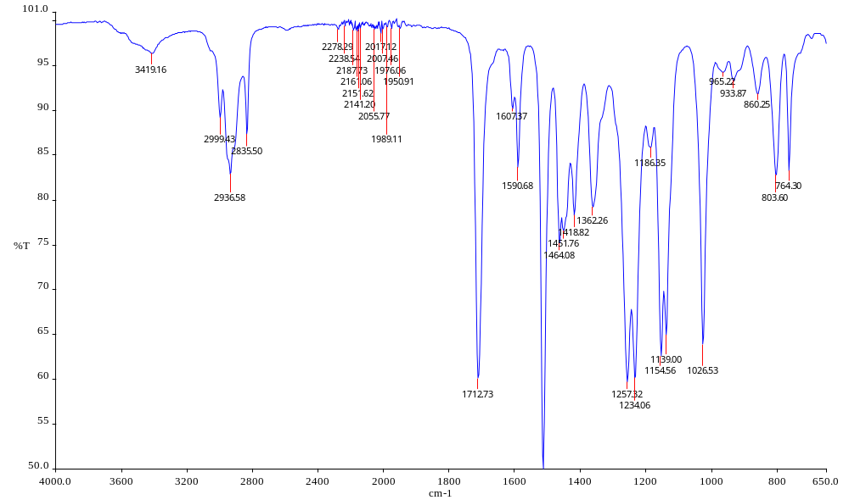
Figure S3. IR spectra of 4-(3,4-dimethoxyphenyl)butan-2-one (1a).
Figure S4. ¹H NMR spectra of 4-(4-ethoxy-3-methoxyphenyl)butan-2-one (1b).

Figure S5. ¹³C NMR spectra of 4-(4-ethoxy-3-methoxyphenyl)butan-2-one (1b).

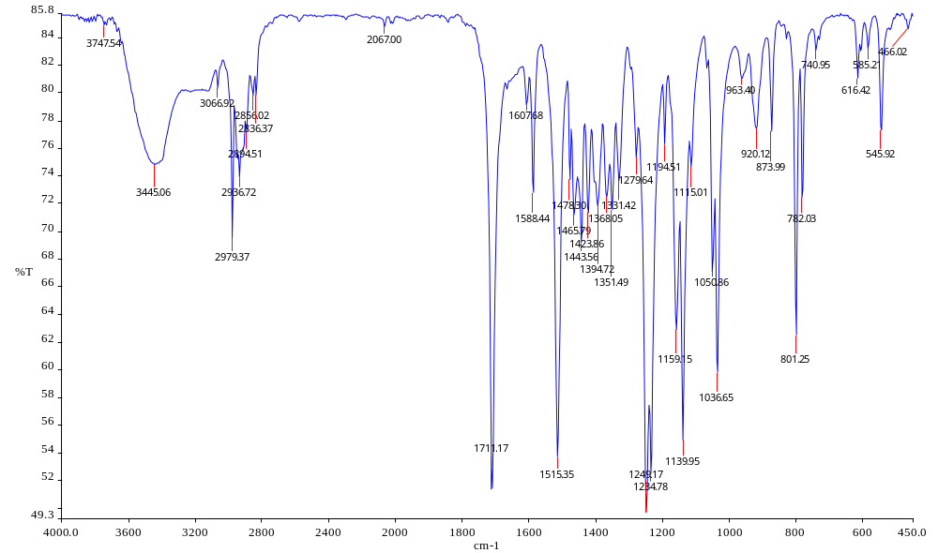
Figure S6. IR spectra of 4-(4-ethoxy-3-methoxyphenyl)butan-2-one (1b).
Figure S7. ¹H NMR spectra of 4-(3-methoxy-4-propoxyphenyl)butan-2-one (1c).

Figure S8. ¹³C NMR spectra of 4-(3-methoxy-4-propoxyphenyl)butan-2-one (1c).

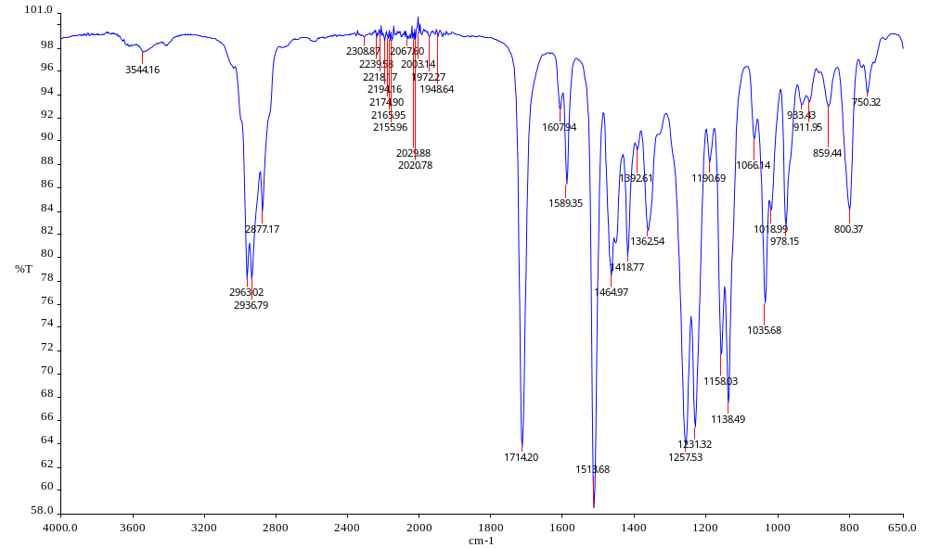
Figure S9. IR spectra of 4-(3-methoxy-4-propoxyphenyl)butan-2-one (1c).

Figure S10. ¹H NMR spectra of 4-(4-isopropoxy-3-methoxyphenyl)butan-2-one (1d).
Figure S11. ¹³C NMR spectra of 4-(4-isopropoxy-3-methoxyphenyl)butan-2-one (1d).

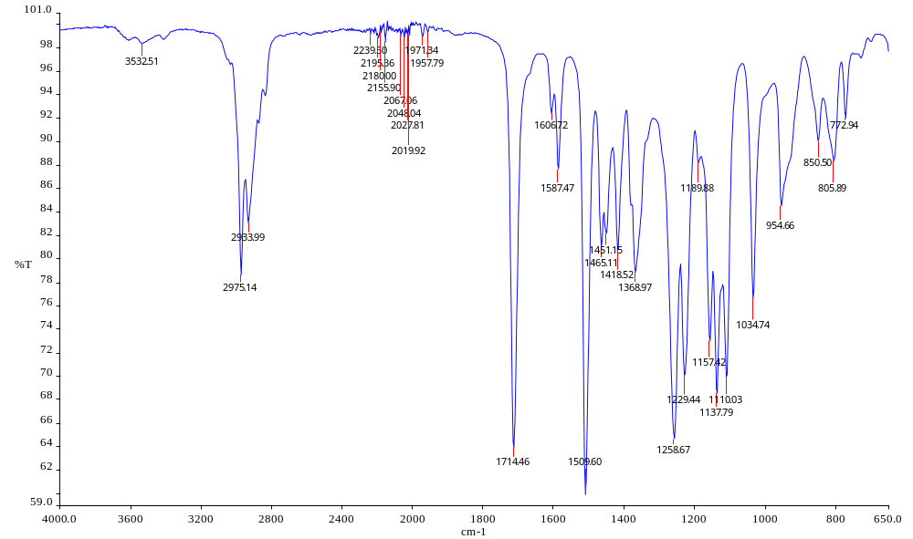
Figure S12. IR spectra of 4-(4-isopropoxy-3-methoxyphenyl)butan-2-one (1d).
Figure S13. ¹H NMR spectra of 4-(4-butoxy-3-methoxyphenyl)butan-2-one (1e).

Figure S14. ¹³C NMR spectra of 4-(4-butoxy-3-methoxyphenyl)butan-2-one (1e).

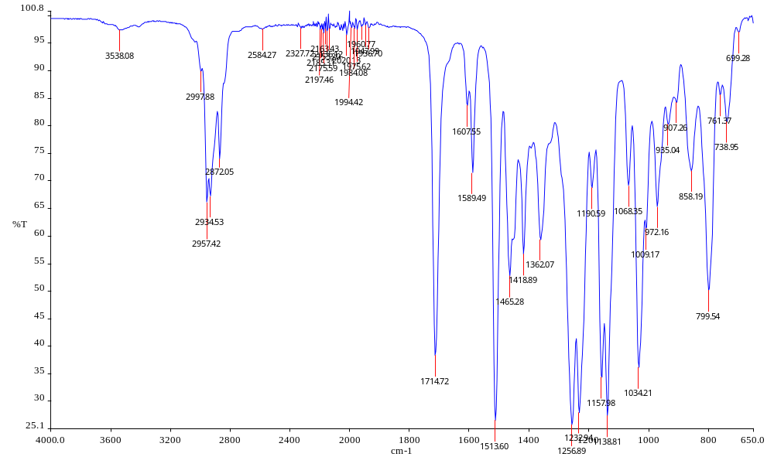
Figure S15. IR spectra of 4-(4-butoxy-3-methoxyphenyl)butan-2-one (1e).

Figure S16. ¹H NMR spectra of 4-(4-(benzyloxy)-3-methoxyphenyl)butan-2-one (1f).

Figure S17. ¹³C NMR spectra of 4-(4-(benzyloxy)-3-methoxyphenyl)butan-2-one (1f).

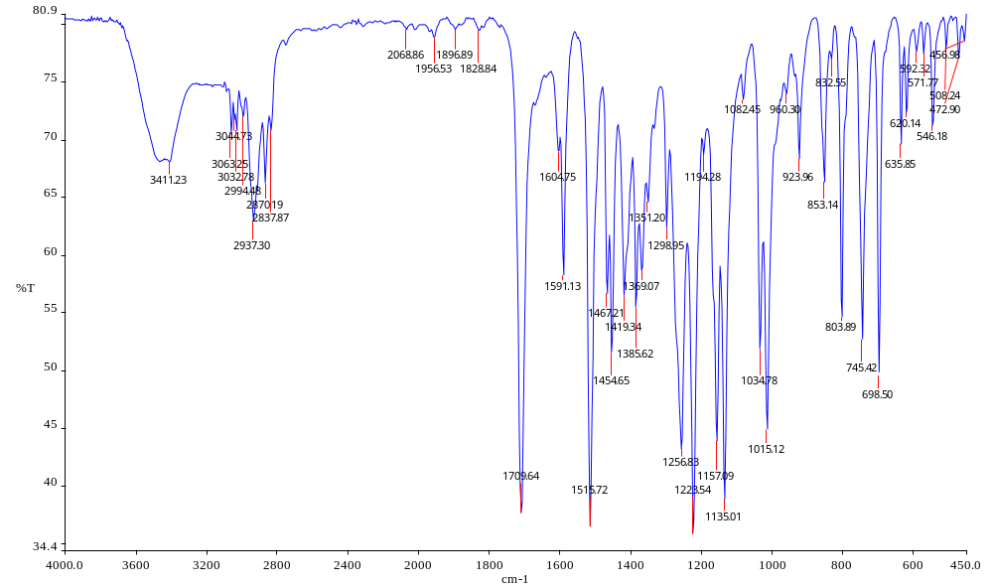
Figure S18. IR spectra of 4-(4-(benzyloxy)-3-methoxyphenyl)butan-2-one (1f).

Figure S19. ¹H NMR spectra of 4-(3-methoxy-4-((2-methylallyl)oxy)phenyl)butan-2-one (1g).

Figure S20. ¹³C NMR spectra of 4-(3-methoxy-4-((2-methylallyl)oxy)phenyl)butan-2-one (1g).

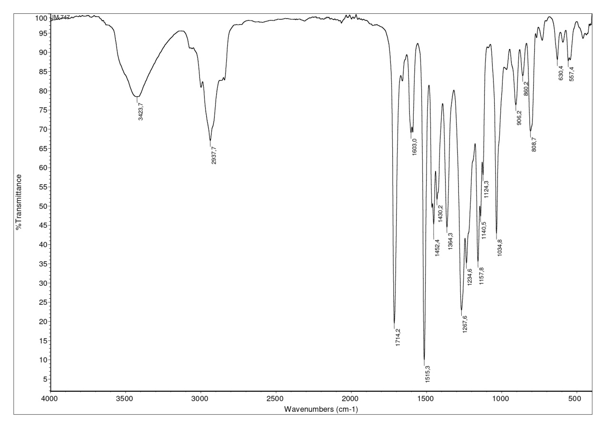
Figure S21. IR spectra of 4-(3-methoxy-4-((2-methylallyl)oxy)phenyl)butan-2-one (1g).

Figure S22. ¹H NMR spectra of 3-((4-(3,4-dimethoxyphenyl)butan-2-ylidene)amino)-2-thioxoimidazolidin-4-one (2a).
Figure S23. ¹³C NMR spectra of 3-((4-(3,4-dimethoxyphenyl)butan-2-ylidene)amino)-2-thioxoimidazolidin-4-one (2a).
Figure S24. IR spectra of 3-((4-(3,4-dimethoxyphenyl)butan-2-ylidene)amino)-2-thioxoimidazolidin-4-one (2a).
Figure S25. ¹H NMR spectra of 3-((4-(4-ethoxy-3-methoxyphenyl)butan-2-ylidene)amino)-2-thioxoimidazolidin-4-one (2b).
Figure S26. ¹³C NMR spectra of 3-((4-(4-ethoxy-3-methoxyphenyl)butan-2-ylidene)amino)-2-thioxoimidazolidin-4-one (2b).
Figure S27. IR spectra of 3-((4-(4-ethoxy-3-methoxyphenyl)butan-2-ylidene)amino)-2-thioxoimidazolidin-4-one (2b).

Figure S28. ¹H NMR spectra of 3-((4-(3-methoxy-4-propoxyphenyl)butan-2-ylidene)amino)-2-thioxoimidazolidin-4-one (2c).
Figure S29. ¹³C NMR spectra of 3-((4-(3-methoxy-4-propoxyphenyl)butan-2-ylidene)amino)-2-thioxoimidazolidin-4-one (2c).
Figure S30. IR spectra of 3-((4-(3-methoxy-4-propoxyphenyl)butan-2-ylidene)amino)-2-thioxoimidazolidin-4-one (2c).
Figure S31. ¹H NMR spectra of 3-((4-(4-isopropoxy-3-methoxyphenyl)butan-2-ylidene)amino)-2-thioxoimidazolidin-4-one (2d).
Figure S32. ¹³C NMR spectra of 3-((4-(4-isopropoxy-3-methoxyphenyl)butan-2-ylidene)amino)-2-thioxoimidazolidin-4-one (2d).
Figure S33. IR spectra of 3-((4-(4-isopropoxy-3-methoxyphenyl)butan-2-ylidene)amino)-2-thioxoimidazolidin-4-one (2d).

Figure S34. ¹H NMR spectra of 3-((4-(4-butoxy-3-methoxyphenyl)butan-2-ylidene)amino)-2-thioxoimidazolidin-4-one (2e)
Figure S35. ¹³C NMR spectra of 3-((4-(4-butoxy-3-methoxyphenyl)butan-2-ylidene)amino)-2-thioxoimidazolidin-4-one (2e).
Figure S36. IR spectra of 3-((4-(4-butoxy-3-methoxyphenyl)butan-2-ylidene)amino)-2-thioxoimidazolidin-4-one (2e).
Figure S37. ¹H NMR spectra of 3-((4-(4-(benzyloxy)-3-methoxyphenyl)butan-2-ylidene)amino)-2-thioxoimidazolidin-4-one (2f).
Figure S38. ¹³C NMR spectra of 3-((4-(4-(benzyloxy)-3-methoxyphenyl)butan-2-ylidene)amino)-2-thioxoimidazolidin-4-one (2f).
Figure S39. IR spectra of 3-((4-(4-(benzyloxy)-3-methoxyphenyl)butan-2-ylidene)amino)-2-thioxoimidazolidin-4-one (2f).
Figure S40. ¹H NMR spectra of 3-((4-(3-methoxy-4-((2-methylallyl)oxy)phenyl)butan-2-ylidene)amino)-2-thioxoimidazolidin-4-one (2g).

Figure S41. ¹³C NMR spectra of 3-((4-(3-methoxy-4-((2-methylallyl)oxy)phenyl)butan-2-ylidene)amino)-2-thioxoimidazolidin-4-one (2g).
Figure S42. IR spectra of 3-((4-(3-methoxy-4-((2-methylallyl)oxy)phenyl)butan-2-ylidene)amino)-2-thioxoimidazolidin-4-one (2g).

Table S1. LC-HRMS analysis for compounds 2a-g.
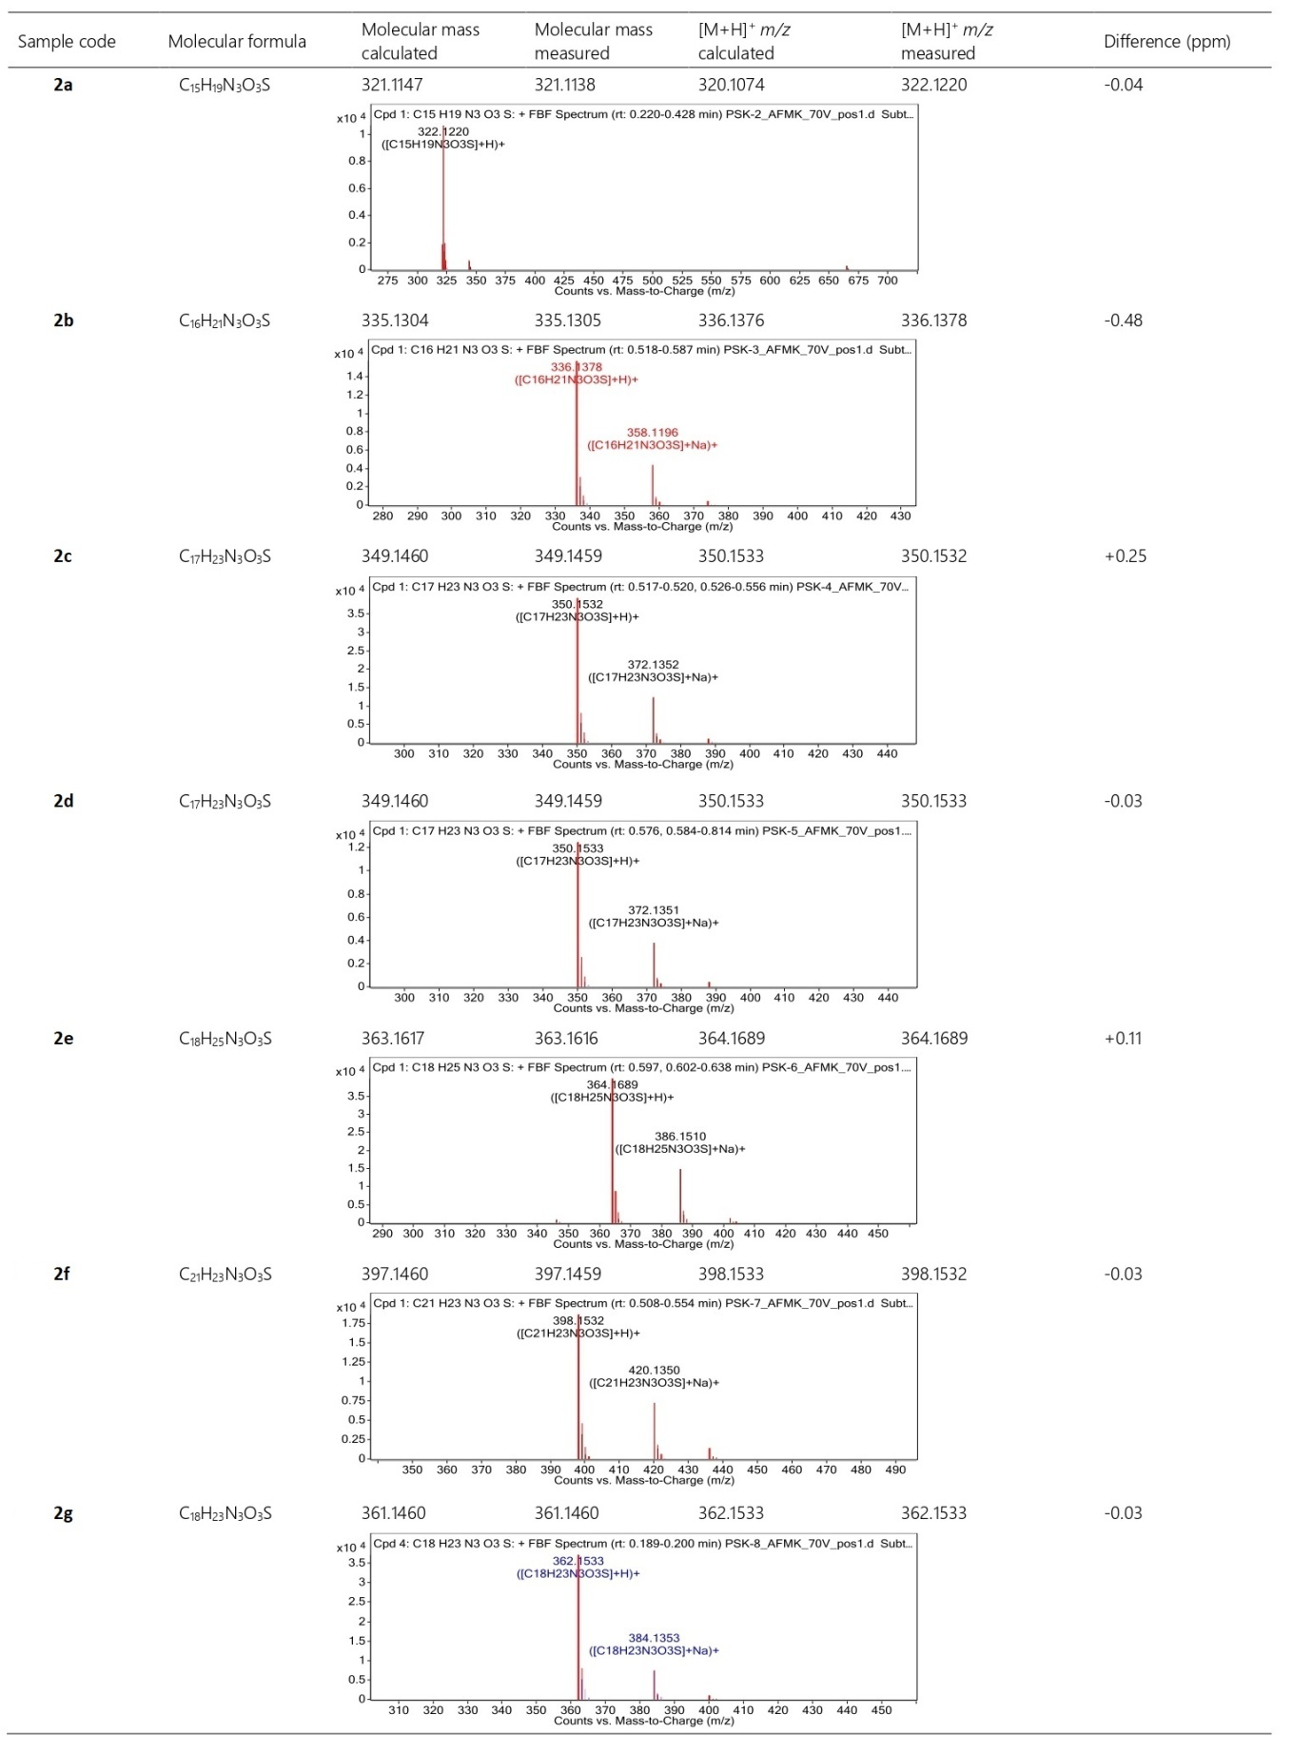

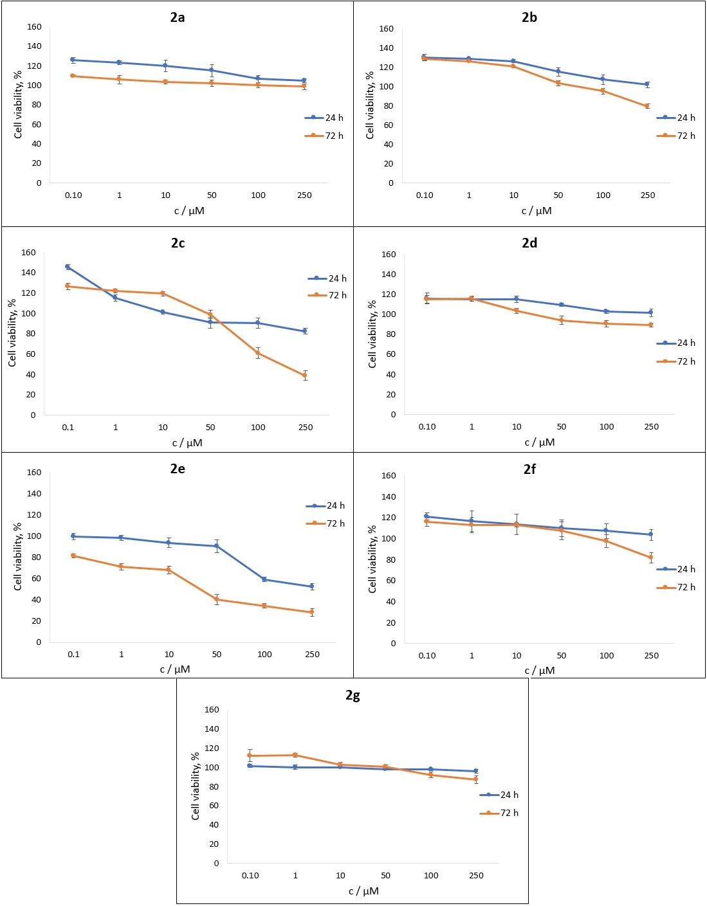
Figure S43. The effects of zingerone-thiohydantoin derivatives on MDA-MB-231 cell viability.

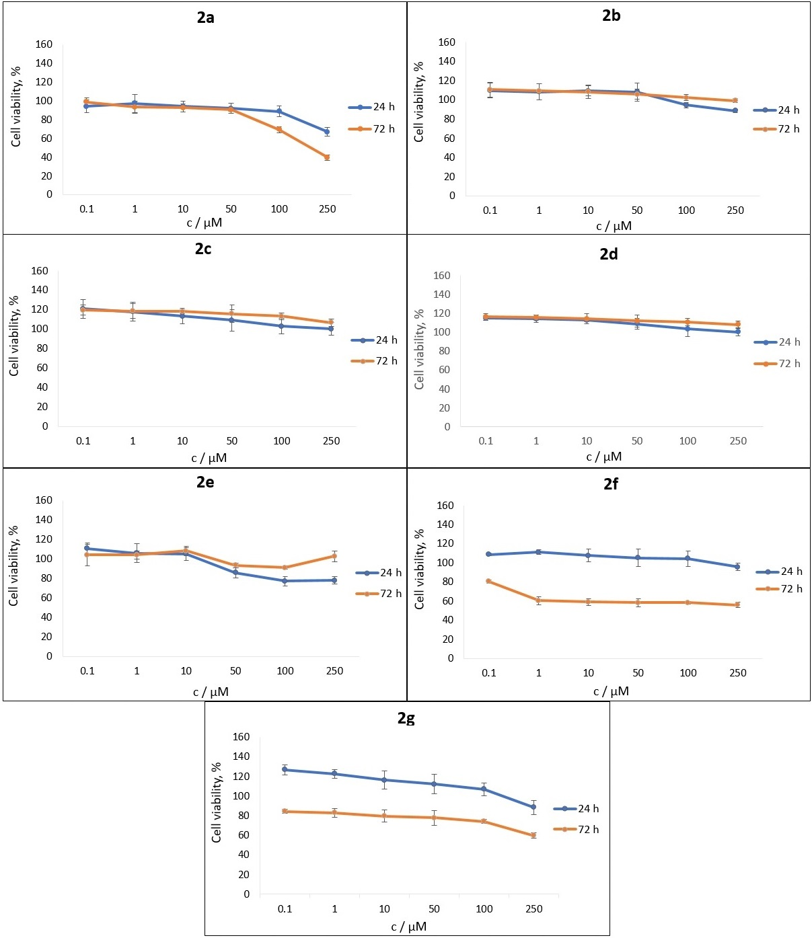
Fig. S44. The effects of zingerone-thiohydantoin derivatives on MRC-5 cell viability.

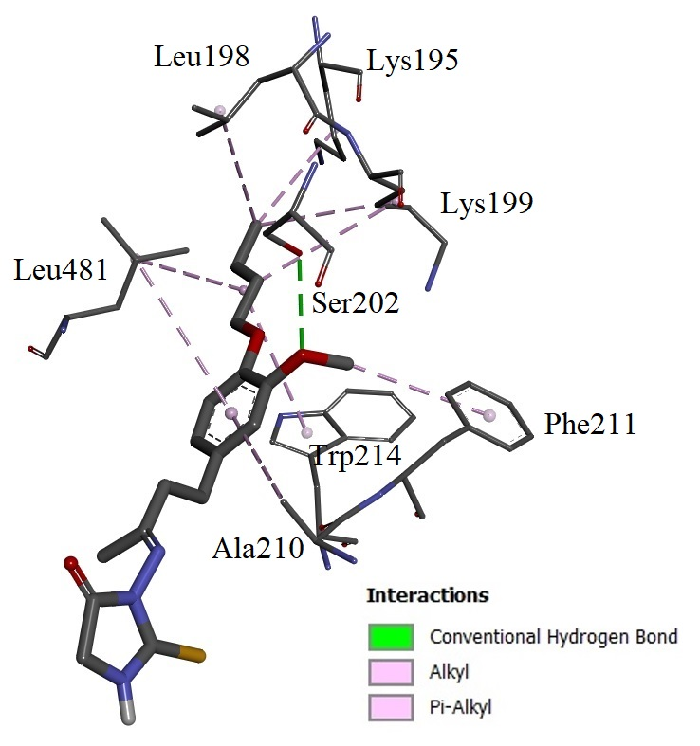
Figure S45. Amino acid environment and interactions of 2e in BS2 of HSA.

Bcl-2 (Table S2, entry 1) is an anti-apoptotic protein and its primary function is the prevention of programmed cell death (apoptosis). It is an important marker for clinical breast cancer prognosis and its up-regulation is linked to breast cancer survival and progression.¹ Published research shows that targeting Bcl-2 and its down-regulation effectively induces cell death in breast cancer cells.²
Vascular endothelial growth factor, VEGF (Table S2, entry 2), promotes the growth and metastasis of MDA-MB-231 triple-negative breast cancer cells by inducing angiogenesis, increasing cell adhesion and reducing apoptosis through Bcl-2 expression. It acts as a survival factor and facilitates the penetration of these cells across endothelial monolayers.³
Topoisomerase II alpha, Top2A (Table S2, entry 3), is a critical enzyme for DNA replication and a target for chemotherapy. TOP2A is essential in MDA-MB-231 triple-negative breast cancer cells for resolving DNA topological constraints, enabling rapid proliferation and facilitating mitosis by managing chromosome condensation and segregation. It is a critical biomarker for therapy in triple-negative breast cancer models.⁴
Thymidylate synthase, TS (Table S2, entry 4), is a critical enzyme for DNA synthesis and repair in triple-negative breast cancer cells, converting dUMP to dTMP for cell proliferation. Overexpressed in these cells, TS supports a highly proliferative, metastatic phenotype and is associated with poor prognosis and chemoresistance.⁵
Janus kinase 2, JAK2 (Table S2, entry 5), acts as a critical mediator of proliferation, survival, and migration in triple-negative breast cancer cells, primarily through activation of the JAK2/STAT3 pathway. Inhibiting JAK2 reduces tumor growth, induces apoptosis and suppresses metastasis by decreasing phosphorylation of STAT3 and related, downstream oncogenic signals.⁶
Nuclear factor kappa B, NF-κB (Table S2, entries 6-8), is heavily activated in MDA-MB-231 triple-negative breast cancer cells, promoting tumor aggressiveness, metastasis and survival. It drives cancer progression by regulating epithelial-mesenchymal transition transcription factors (such as SLUG, TWIST1), inducing chemoresistance and facilitating angiogenesis.⁷
Topoisomerase I, Top1 (Table S2, entry 9), plays a critical role in triple-negative breast cancer cells by relieving DNA torsional strain during rapid replication and transcription. Due to the high proliferation rate of these cells, they express high levels of Top1, making them highly sensitive to inhibiting agents like topotecan.⁸
Cyclooxygenase-2, COX-2 (Table S2, entry 10), is heavily overexpressed in highly aggressive, triple-negative breast cancer cells, playing a key role in driving malignant phenotypes, including rapid tumor growth, increased invasion, migration, angiogenesis and radioresistance. Inhibiting COX-2 (through siRNA or drugs like celecoxib) reverses these processes, making it a critical target for reducing cancer progression.⁹
Poly [ADP-ribose] polymerase 1, PARP-1 (Table S2, entry 11), promotes DNA damage repair, cell survival and resistance to chemotherapy in triple-negative breast cancer cells, notably by facilitating the epithelial-mesenchymal transition. Inhibition of PARP-1 induces apoptosis, reduces cell growth, increases oxidative stress and acts as a chemosensitizer.¹⁰
Tumor necrosis factor alpha receptors, TNF-α (Table S2, entries 12-14), primarily drive tumor progression by promoting growth, migration and invasion. TNF-α activate these receptors to induce matrix metalloproteinases, enhancing metastatic potential. They also contribute to chemotherapy resistance.¹¹
Dihydroorotate dehydrogenase, DHODH (Table S2, entry 15) is a critical enzyme for de novo pyrimidine synthesis and mitochondrial respiration, making it a key survival factor in triple-negative breast cancer cells. It is overexpressed in these cells and its inhibition induces significant ATP depletion, S-phase cell cycle arrest, increased ROS production and apoptosis.¹²
Bromodomain-containing protein 2, BRD2 (Table S2, entries 16-17), acts as an epigenetic reader that promotes the proliferation and survival of triple-negative breast cancer cells by regulating the expression of oncogenes. It interprets acetylated histone residues, driving expression of genes involved in cell cycle progression. Inhibiting BRD2 proteins induces apoptosis and cell cycle arrest.¹³
Human Kinesin-5, Eg5 (Table S2, entry 18), is essential for mitosis, primarily driving bipolar spindle formation by separating centrosomes. Overexpression of Eg5 in triple negative breast cancer cells supports rapid cancer proliferation, while its inhibition induces mitotic catastrophe, monoastral spindle formation and apoptosis.¹⁴
Phosphoinositide 3-kinase, PI3K (Table S2, entry 19), has a central role in oncogenic signaling. Because triple negative breast cancer cells lack estrogen, progesterone and human epidermal growth factor receptors, they rely heavily on the PI3K/Akt/mTOR pathway and its down-regulation inhibits their survival and progression.¹⁵
Human placental aromatase, CYP19A1 (Table S2, entry 20), plays several unconventional roles in triple negative breast cancer, despite the cells being hormone-independent. Aromatase inhibitors have been shown to inhibit the formation of lung metastases and reduce tumor growth. Estrogen in the microenvironment, produced by local aromatase, can stimulate neighboring cells like astrocytes or fibroblasts. These cells then release factors that promote triple negative breast cancer migration and invasion, which can be blocked by aromatase inhibitors.¹⁶
Maternal embryonic leucine zipper kinase, MELK (Table S2, entry 21) promotes high proliferation, metastasis and cancer stem cell phenotypes, primarily through regulating cell cycle progression (G₂/M) arrest) and increasing cell motility. Silencing or inhibiting reduces tumor growth and metastasis in pre-clinical models of triple negative breast cancer.¹⁷
AKT serine-threonine protein kinase (Table S2, entries 22-23) primarily promotes cell proliferation and survival by regulating cell cycle proteins like Cyclin D1. Notably, it can act as a suppressor of metastasis. Its inhibition often leads to increased epithelial-to-mesenchymal transition, enhanced cell migration and increased radioresistance. It is generally associated with promoting migration, invasion, and metastasis.¹⁸
Cyclin-dependent kinases, CDKs (Table S2, entries 24-26), in triple-negative breast cancer are drivers of rapid cell-cycle progression, migration and survival. They are identified as major regulators promoting tumor proliferation. CDK inhibitors induce cell-cycle arrest, apoptosis and inhibit migration, while also enhancing immune checkpoint blockade.¹⁹
Anaplastic Lymphoma Kinase, ALK (Table S2, entry 27), acts as an oncogenic driver that promotes aggressive behavior, including cell survival, migration and invasion. ALK is overexpressed in triple-negative breast cancer and contributes to resistance against TGF-β (transforming growth factor-beta) mediated growth inhibition.²⁰
Proto-oncogene tyrosine-protein kinase 1, ROS1 (Table S2, entry 28), functions as a potential driver of tumor growth and a target for therapeutic sensitization. ROS1 is a receptor tyrosine kinase involved in signaling pathways that regulate cell growth, survival, and differentiation. Its activation triggers the Akt and ERK pathways, which are critical for processing signals from growth factors, ultimately promoting proliferation, motility and apoptosis resistance.²¹
Programmed cell death 1 ligand 1, PD-L1 (Table S2, entry 29), is highly expressed in triple negative breast cancer and plays a crucial role in promoting cancer progression. It acts as an oncogenic driver, fueling cell proliferation, colony formation, migration and invasion via the Akt and ERK signaling pathways.²²
Sirtuin 1, SIRT1 (Table S2, entry 30), acts primarily as an oncogene in triple-negative breast cancer cells, promoting tumor proliferation, metastasis and chemotherapy resistance. Overexpression of SIRT1 enhances cell growth, while its inhibition or knockdown leads to increased apoptosis and reduced migration. However, some studies indicate it may play complex roles, sometimes acting to regulate cell secretome components.²³
Histone deacetylases, HDACs (Table S2, entries 31-32), are overexpressed in triple negative cancer cells, promoting aggressive characteristics like increased proliferation, migration, invasion and metastatic potential. They facilitate these processes by regulating gene expression and promoting the stability of oncogenic proteins.²⁴
Heat shock protein 90, Hsp90 (Table S2, entry 33), plays a critical role in the survival, metastasis and therapy resistance of triple-negative breast cancer cells. It acts as a molecular chaperone, stabilizing oncoproteins like FAK, Bcl-2 and EGFR. Notably, triple-negative breast cancer cells secrete Hsp90α to survive hypoxia and promote migration and invasion, making it a key therapeutic target.²⁵
Isocitrate dehydrogenase (Table S2, entry 34) plays a critical role in supporting triple-negative breast cancer viability by promoting tumor cell proliferation, migration and survival. High isocitrate dehydrogenase expression in these cells is linked to poor prognosis, acting partly by inhibiting ferroptosis. Inhibiting isocitrate dehydrogenase results in cell cycle arrest at G0/G1 and increased apoptosis.²⁶
Beta-2 adrenergic receptor, β2AR (Table S2, entry 35), acts as a key mediator of stress-induced tumor progression, facilitating increased migration, invasion and metastasis. β2AR signaling promotes a mesenchymal-like morphology and activates pathways that increase cellular stiffness and traction forces, such as the βAR-RhoA-ROCK-non-muscle myosin II (NMII) axis. β2AR is a significant promoter of the aggressive, metastatic phenotype in triple-negative breast cancer cells, particularly under stressful conditions. ²⁷

Table S2. Binding free energies (ΔG / kcal mol⁻¹) and binding sites of investigated compounds with other potential breast adenocarcinoma targets.
 | Target | Ligand | Binding sites
1 | B-cell lymphoma 2 (Bcl-2)  PDB ID: 4AQ3²⁸ |  | Non-inhibiting site (BS1) |  |  | Inhibiting site (BS2)
1 | B-cell lymphoma 2 (Bcl-2)  PDB ID: 4AQ3²⁸ | 2e | -7.7 |  |  | -7.1
1 | B-cell lymphoma 2 (Bcl-2)  PDB ID: 4AQ3²⁸ | 2a | -7.0 |  |  | -6.3
2 | Vascular endothelial growth factor (VEGF) PDB ID: 4ASD²⁹ |  | Inhibiting site (BS1) |  |  | Non-inhibiting site (BS2) |  |  |  | Non-inhibiting site (BS3)
2 | Vascular endothelial growth factor (VEGF) PDB ID: 4ASD²⁹ | 2e | -7.9 |  |  | -7.5
2 | Vascular endothelial growth factor (VEGF) PDB ID: 4ASD²⁹ | 2a | -7.5 |  |  |  |  |  |  | -7.4
3 | Topoisomerase II alpha (Top2A)  PDB ID: 1ZXM³⁰ |  | Catalytic site (BS1)
3 | Topoisomerase II alpha (Top2A)  PDB ID: 1ZXM³⁰ | 2e | -8.6
3 | Topoisomerase II alpha (Top2A)  PDB ID: 1ZXM³⁰ | 2a | -7.9
4 | Thymidylate synthase (TS)  PDB ID: 6QXG³¹ |  | Inhibiting site (BS1)
4 | Thymidylate synthase (TS)  PDB ID: 6QXG³¹ | 2e | -9.2
4 | Thymidylate synthase (TS)  PDB ID: 6QXG³¹ | 2a | -8.1
5 | Janus kinase 2 (JAK2)  PDB ID: 3KRR³² |  | Inhibiting site (BS1) | Non-inhibiting site (BS2) |  |  |  | Non-inhibiting site (BS3)
5 | Janus kinase 2 (JAK2)  PDB ID: 3KRR³² | 2e | -7.7 | -7.5 |  |  |  | -7.5
5 | Janus kinase 2 (JAK2)  PDB ID: 3KRR³² | 2a | -7.3 | -6.8 |  |  |  | -6.7
6 | Nuclear factor kappa B (NF-κB) p50  PDB ID: 1NFK³³ |  | Non-inhibiting site (BS1)
6 | Nuclear factor kappa B (NF-κB) p50  PDB ID: 1NFK³³ | 2e | -7.6
6 | Nuclear factor kappa B (NF-κB) p50  PDB ID: 1NFK³³ | 2a | -7.1
7 | Nuclear factor kappa B (NF-κB) p52  PDB ID: 1A3Q³⁴ |  | Non-inhibiting site (BS1)
7 | Nuclear factor kappa B (NF-κB) p52  PDB ID: 1A3Q³⁴ | 2e | -6.9
7 | Nuclear factor kappa B (NF-κB) p52  PDB ID: 1A3Q³⁴ | 2a | -6.2
8 | Nuclear factor kappa B (NF-κB) p65  PDB ID: 1MY5³⁵ |  | Non-inhibiting site (BS1)
8 | Nuclear factor kappa B (NF-κB) p65  PDB ID: 1MY5³⁵ | 2e | -6.9
8 | Nuclear factor kappa B (NF-κB) p65  PDB ID: 1MY5³⁵ | 2a | -6.6
9 | Topoisomerase I (Top1)  PDB ID: 1K4T³⁶ |  | Non-inhibiting site (BS1)
9 | Topoisomerase I (Top1)  PDB ID: 1K4T³⁶ | 2e | -9.9
9 | Topoisomerase I (Top1)  PDB ID: 1K4T³⁶ | 2a | -8.6
10 | Cyclooxygenase-2 (COX-2)  PDB ID: 3LN1³⁷ |  | Non-inhibiting site (BS1) |  | Non-inhibiting site (BS2) |  |  |  | Non-inhibiting site (BS3)
10 | Cyclooxygenase-2 (COX-2)  PDB ID: 3LN1³⁷ | 2e | -9.0 |  | -9.0 |  |  |  | -8.8
10 | Cyclooxygenase-2 (COX-2)  PDB ID: 3LN1³⁷ | 2a | -8.1 |  | -8.8 |  |  |  | -8.1
11 | Poly [ADP-ribose] polymerase 1 (PARP-1) PDB ID: 4R6E³⁸ |  | Inhibiting site (BS1)
11 | Poly [ADP-ribose] polymerase 1 (PARP-1) PDB ID: 4R6E³⁸ | 2e | -8.9
11 | Poly [ADP-ribose] polymerase 1 (PARP-1) PDB ID: 4R6E³⁸ | 2a | -8.7
12 | Tumor necrosis factor alpha receptor (TNF-α) PDB ID: 1TNF³⁹ |  | Binding site (BS1)
12 | Tumor necrosis factor alpha receptor (TNF-α) PDB ID: 1TNF³⁹ | 2e | -9.3
12 | Tumor necrosis factor alpha receptor (TNF-α) PDB ID: 1TNF³⁹ | 2a | -8.6
13 | Tumor necrosis factor alpha receptor mutant (TNF-α) PDB ID: 2TUN⁴⁰ |  | Binding site (BS1)
13 |  | 2e | -10.0
13 |  | 2a | -9.1
14 | Tumor necrosis factor alpha receptor mutant (TNF-α) PDB ID: 5TSW⁴¹ |  | Binding site (BS1)
14 |  | 2e | -8.6
14 |  | 2a | -8.6
15 | Dihydroorotate dehydrogenase (DHODH) PDB ID: 6GK0⁴² |  | Allosteric site (BS1) |  |  |  | Non-inhibiting site (BS2)
15 | Dihydroorotate dehydrogenase (DHODH) PDB ID: 6GK0⁴² | 2e | -7.7 |  |  |  | -7.3
15 | Dihydroorotate dehydrogenase (DHODH) PDB ID: 6GK0⁴² | 2a | -7.2 |  |  |  | -7.3
16 | Bromodomain-containing protein 2 (BRD2) bromodomain 1 (BD1)  PDB ID: 6K05⁴³ |  | Binding site (BS1)
16 |  | 2e | -7.3
16 |  | 2a | -6.7
17 | Bromodomain-containing protein 2 (BRD2) bromodomain 2 (BD2)  PDB ID: 6K04⁴³ |  | Out of binding site (BS1) |  |  |  | Binding site (BS2)
17 |  | 2e | -6.9 |  |  |  | -6.7
17 |  | 2a |  |  |  |  | -6.8
18 | Human Kinesin-5 (Eg5)  PDB ID: 4A5Y⁴⁴ |  | Inhibiting site (BS1)
18 | Human Kinesin-5 (Eg5)  PDB ID: 4A5Y⁴⁴ | 2e | -8.0
18 | Human Kinesin-5 (Eg5)  PDB ID: 4A5Y⁴⁴ | 2a | -7.5
19 | Phosphoinositide 3-kinase (PI3K) PDB ID: 4XE0⁴⁵ |  | Non-inhibiting site (BS1) |  | Non-inhibiting site (BS2) |  |  |  | Non-inhibiting site (BS3)
19 | Phosphoinositide 3-kinase (PI3K) PDB ID: 4XE0⁴⁵ | 2e | -9.6 |  | -9.1
19 | Phosphoinositide 3-kinase (PI3K) PDB ID: 4XE0⁴⁵ | 2a |  |  | -8.2 |  |  |  | -8.4
20 | Human placental aromatase  PDB ID: 3EQM⁴⁶ |  | Non-inhibiting site (BS1) |  |  |  | Non-inhibiting site (BS2)
20 | Human placental aromatase  PDB ID: 3EQM⁴⁶ | 2e | -7.0
20 | Human placental aromatase  PDB ID: 3EQM⁴⁶ | 2a | -6.9 |  |  |  | -7.6
21 | Maternal Embryonic Leucine zipper Kinase (MELK) PDB ID: 4BKY⁴⁷ |  | Non-inhibiting site (BS1) |  |  |  | Inhibiting site (BS2)
21 |  | 2e | -8.5 |  |  |  | -8.0
21 |  | 2a | -7.4 |  |  |  | -7.8
22 | AKT serine-threonine protein kinase 1 PDB ID: 3O96⁴⁸ |  | Inhibiting site (BS2)
22 | AKT serine-threonine protein kinase 1 PDB ID: 3O96⁴⁸ | 2e | -10.0
22 | AKT serine-threonine protein kinase 1 PDB ID: 3O96⁴⁸ | 2a | -8.8
23 | AKT serine-threonine protein kinase 2 PDB ID: 3D0E⁴⁹ |  | Inhibiting site (BS1) |  |  |  | Non-inhibiting site (BS2)
23 | AKT serine-threonine protein kinase 2 PDB ID: 3D0E⁴⁹ | 2e | -7.9 |  |  |  | -7.3
23 | AKT serine-threonine protein kinase 2 PDB ID: 3D0E⁴⁹ | 2a | -7.6 |  |  |  | -6.9
24 | Cyclin-dependent kinase 1 (CDK1) PDB ID: 6GU2⁵⁰ |  | Inhibiting site (BS1) |  |  |  | Non-inhibiting site (BS2)
24 | Cyclin-dependent kinase 1 (CDK1) PDB ID: 6GU2⁵⁰ | 2e | -7.8 |  |  |  | -7.4
24 | Cyclin-dependent kinase 1 (CDK1) PDB ID: 6GU2⁵⁰ | 2a | -7.2 |  |  |  | -6.8
25 | Cyclin-dependent kinase 2 (CDK2) PDB ID: 8FP0⁵¹ |  | Inhibiting site (BS1)
25 | Cyclin-dependent kinase 2 (CDK2) PDB ID: 8FP0⁵¹ | 2e | -8.5
25 | Cyclin-dependent kinase 2 (CDK2) PDB ID: 8FP0⁵¹ | 2a | -8.1
26 | Cyclin-dependent kinase 6 (CDK6) PDB ID: 5L2T⁵² |  | Inhibiting site (BS1) |  |  |  | Non-inhibiting site (BS2)
26 | Cyclin-dependent kinase 6 (CDK6) PDB ID: 5L2T⁵² | 2e | -7.4 |  |  |  | -6.9
26 | Cyclin-dependent kinase 6 (CDK6) PDB ID: 5L2T⁵² | 2a | -7.7
27 | Anaplastic lymphoma kinase (ALK) PDB ID: 5FTO⁵³ |  | Inhibiting site (BS1)
27 | Anaplastic lymphoma kinase (ALK) PDB ID: 5FTO⁵³ | 2e | -7.4
27 | Anaplastic lymphoma kinase (ALK) PDB ID: 5FTO⁵³ | 2a | -8.0
28 | Proto-oncogene tyrosine-protein kinase (ROS1) PDB ID: 3ZBF⁵⁴ |  | Inhibiting site (BS1) |  |  |  | Non-inhibiting site (BS2)
28 | Proto-oncogene tyrosine-protein kinase (ROS1) PDB ID: 3ZBF⁵⁴ | 2e | -7.6 |  |  |  | -7.1
28 | Proto-oncogene tyrosine-protein kinase (ROS1) PDB ID: 3ZBF⁵⁴ | 2a | -6.4 |  |  |  | -6.9
29 | Programmed cell death 1 ligand 1 (PD-L1) PDB ID: 5J89⁵⁵ |  | Inhibiting site (BS1) |  | Non-inhibiting site (BS2) |  |  |  | Non-inhibiting site (BS3)
29 | Programmed cell death 1 ligand 1 (PD-L1) PDB ID: 5J89⁵⁵ | 2e | -7.1 |  | -6.5
29 | Programmed cell death 1 ligand 1 (PD-L1) PDB ID: 5J89⁵⁵ | 2a | -6.6 |  |  |  |  |  | -6.0
30 | Sirtuin 1 (SIRT1)  PDB ID: 4I5I⁵⁶ |  | Non-inhibiting site (BS1)
30 | Sirtuin 1 (SIRT1)  PDB ID: 4I5I⁵⁶ | 2e | -8.5
30 | Sirtuin 1 (SIRT1)  PDB ID: 4I5I⁵⁶ | 2a | -7.8
31 | Histone deacetylase 4 (HDAC4)  PDB ID: 2VQJ⁵⁷ |  | Active site (BS1) |  |  |  | Non-inhibiting site (BS2)
31 | Histone deacetylase 4 (HDAC4)  PDB ID: 2VQJ⁵⁷ | 2e | -7.5 |  |  |  | -8.1
31 | Histone deacetylase 4 (HDAC4)  PDB ID: 2VQJ⁵⁷ | 2a | -7.4 |  |  |  | -7.4
32 | Histone deacetylase 6 (HDAC6)  PDB ID: 5EDU⁵⁸ |  | Non-inhibiting site (BS1)
32 | Histone deacetylase 6 (HDAC6)  PDB ID: 5EDU⁵⁸ | 2e | -8.7
32 | Histone deacetylase 6 (HDAC6)  PDB ID: 5EDU⁵⁸ | 2a | -8.5
33 | Heat shock protein 90 (Hsp90)  PDB ID: 3TUH⁵⁹ |  | Inhibiting site (BS1) |  |  |  | Non-inhibiting site (BS2)
33 | Heat shock protein 90 (Hsp90)  PDB ID: 3TUH⁵⁹ | 2e | -7.0 |  |  |  | -6.4
33 | Heat shock protein 90 (Hsp90)  PDB ID: 3TUH⁵⁹ | 2a | -6.8 |  |  |  | -6.0
34 | Isocitrate Dehydrogenase  PBD ID: 4JA8⁶⁰ |  | Non-inhibiting site (BS1) |  | Non-inhibiting site (BS2) |  |  |  | Active site (BS3)
34 | Isocitrate Dehydrogenase  PBD ID: 4JA8⁶⁰ | 2e | -8.0 |  | -7.9 |  |  |  | -7.4
34 | Isocitrate Dehydrogenase  PBD ID: 4JA8⁶⁰ | 2a | -7.3 |  | -7.4 |  |  |  | -7.3
35 | Beta-2 adrenergic receptor (β2AR) PDB ID: 3NY8⁶¹ |  | Binding site (BS1) |  |  |  | Out of binding site (BS2)
35 | Beta-2 adrenergic receptor (β2AR) PDB ID: 3NY8⁶¹ | 2e | -9.9
35 | Beta-2 adrenergic receptor (β2AR) PDB ID: 3NY8⁶¹ | 2a |  |  |  |  | -8.5

Molecular docking results for the beta-2 adrenergic receptor were promising (Table S2, entry number 35, PDB ID: 3NY8), as the active compound 2e bound within the binding site of the receptor, while the inactive compound 2a bound outside the binding site. However, upon inspection of interactions of the compounds with eight other structures of the receptor, deposited in the Protein Data Bank (Table S3), it was found that there was no difference in the binding of the compounds to the receptor. The compounds mostly bind outside of the binding pocket. Only in the structure deposited under PDB ID 3D4S, in which the seven transmembrane helices of the binding pocket are in an open conformation, did both of the compounds bind inside the binding site of the receptor. Also, within the structure deposited under PDB ID 5D5A, the inactive compound bound within the binding pocket, while the active compound bound outside of the binding pocket. The overall results indicate that the binding modes within the first investigated crystal structure (PDB ID: 3NY8) were due to the specific conformation of the receptor within that structure and that the beta-2 adrenergic receptor is not a likely target responsible for the anticancer activity of the investigated compounds.

Table S3. Binding free energies (ΔG / kcal mol⁻¹) and binding sites of investigated compounds with other structures of beta-2 adrenergic receptor deposited in the Protein Data Bank.
Beta-2 adrenergic receptor (β2AR) | Ligand | Binding site (BS1) | Out of binding site (BS2)
PDB ID: 3PDS⁶² | 2e |  | -9.8
PDB ID: 3PDS⁶² | 2a |  | -7.4
PDB ID: 3D4S⁶³ | 2e | -8.9
PDB ID: 3D4S⁶³ | 2a | -7.8
PDB ID: 2RH1⁶⁴ | 2e |  | -8.8
PDB ID: 2RH1⁶⁴ | 2a |  | -8.8
PDB ID: 6OBA⁶⁵ | 2e |  | -7.7
PDB ID: 6OBA⁶⁵ | 2a |  | -6.5
PDB ID: 6PRZ⁶⁶ | 2e |  | -8.2
PDB ID: 6PRZ⁶⁶ | 2a |  | -7.6
PDB ID: 5D5A⁶⁷ | 2e |  | -8.8
PDB ID: 5D5A⁶⁷ | 2a | -9.7
PDB ID: 5D6L⁶⁸ | 2e |  | -9.8
PDB ID: 5D6L⁶⁸ | 2a |  | -8.9
PDB ID: 5X7D⁶⁹ | 2e |  | -8.5
PDB ID: 5X7D⁶⁹ | 2a |  | -8.9

References

1. Y. H. Eom, H. S. Kim, A. Lee, B. J. Song and B. J. Chae, J. Breast Cancer 2016, 19, 252. DOI:10.4048/jbc.2016.19.3.252
2. S. Tamanna, E. Perumal and J. Rajanathadurai, Cureus 2024. DOI:10.7759/cureus.65159.
3. G. P. Pidgeon, M. P. Barr, J. H. Harmey, D. A. Foley and D. J. Bouchier-Hayes, Br. J. Cancer 2001, 85, 273–278. DOI:10.1054/bjoc.2001.1876
4. T. Zhou, Y. Niu and Y. Li, Mol. Med. Rep. 2024, 31, 50. DOI:10.3892/mmr.2024.13415
5. S. Song, B. Tian, M. Zhang, X. Gao, L. Jie, P. Liu and J. Li, Clin. Exp. Pharmacol. Physiol. 2021, 48, 279–287. DOI:10.1111/1440-1681.13415
6. Y. Yang, H. Zhou, W. Liu, J. Wu, X. Yue, J. Wang, L. Quan, H. Liu, L. Guo, Z. Wang, X. Lian and Q. Zhang, Oncol. Lett. 2018, 16, 6515-6521. DOI:10.3892/ol.2018.9475.
7. S. M. Smith, Y. L. Lyu and L. Cai, PLoS One 2014, 9, e106966. DOI:10.1371/journal.pone.0106966
8. S. H. Akbas, M. Timur and T. Ozben, J. Surg. Res. 2005, 125, 49–55. DOI:10.1016/j.jss.2004.11.011
9. G. D. Basu, W. S. Liang, D. A. Stephan, L. T. Wegener, C. R. Conley, B. A. Pockaj and P. Mukherjee, Breast Cancer Res. 2006, 8, R69. DOI:10.1186/bcr1626
10. Q. Zhao, T. Lan, S. Su and Y. Rao, Chem. Commun. 2019, 55, 369–372. DOI:10.1039/C8CC07813K
11. Z. Zhang, G. Lin, Y. Yan, X. Li, Y. Hu, J. Wang, B. Yin, Y. Wu, Z. Li and X.-P. Yang, Oncogene 2018, 37, 3456–3470. DOI:10.1038/s41388-018-0221-4
12. M. A. A. Shahhiran, M. F. Abdul Kadir, N. Nor Rashid, P. S. Abdul-Rahman and S. Othman, Histochem. Cell Biol. 2025, 163, 3. DOI:10.1007/s00418-024-02339-0
13. K. M. Tracy, S. Prior, W. T. Trowbridge, J. R. Boyd, P. N. Ghule, S. Frietze, J. L. Stein, G. S. Stein and J. B. Lian, Crit. Rev. Eukaryot. Gene Expr. 2024, 34, 61–71. DOI:10.1615/CritRevEukaryotGeneExpr.2023050109
14. B. C. Guido, L. M. Ramos, D. O. Nolasco, C. C. Nobrega, B. Y. Andrade, A. Pic-Taylor, B. A. Neto and J. R. Corrêa, BMC Cancer 2015, 15, 283. DOI:10.1186/s12885-015-1274-1
15. D. Sliva, M. T. Rizzo and D. English, J. Biol. Chem. 2002, 277, 3150–3157. DOI:10.1074/jbc.M109579200
16. L. Reyes-Vázquez, A. J. A. Hernández and E. S. Calderón-Aranda, Toxicology 2020, 437, 152440. DOI:10.1016/j.tox.2020.152440
17. X. Xie, G. B. Chauhan, R. Edupuganti, T. Kogawa, J. Park, M. Tacam, A. W. Tan, M. Mughees, F. Vidhu, D. D. Liu, J. M. Taliaferro, M. K. Pitner, L. S. Browning, J.-H. Lee, F. Bertucci, Y. Shen, J. Wang, N. T. Ueno, S. Krishnamurthy, G. N. Hortobagyi, D. Tripathy, S. J. Van Laere, G. Bartholomeusz, K. N. Dalby and C. Bartholomeusz, Cancer Res. Commun. 2023, 3, 1078–1092. DOI:10.1158/2767-9764.CRC-22-0330
18. J. Kempska, L. Oliveira-Ferrer, A. Grottke, M. Qi, M. Alawi, F. Meyer, K. Borgmann, F. Hamester, K. Eylmann, M. Rossberg, D. J. Smit, M. Jücker, E. Laakmann, I. Witzel, B. Schmalfeldt, V. Müller and K. Legler, Front. Oncol. 2023, 13, 1129682, DOI:10.3389/fonc.2023.1129682.
19. J. Wu, W. Wang, L. Gao, X. Shao and X. Wang, Cancer 2024, 130, 1449–1463. DOI:10.1002/cncr.35270
20. A. K. Siraj, S. Beg, Z. Jehan, S. Prabhakaran, M. Ahmed, A. R.Hussain, F. Al-Dayel, A. Tulbah, D. Ajarim and K. S. Al-Kuraya, Breast Cancer Res. 2015, 17, 127. DOI:10.1186/s13058-015-0610-3
21. S. Tiash, M. J. Chua and E. H. Chowdhury, Int. J. Oncol. 2016, 48, 2359–2366. DOI:10.3892/ijo.2016.3452
22. D. Alkaabi, K. Arafat, S. Sulaiman, A. M. Al-Azawi and S. Attoub, Int. J. Mol. Sci. 2023, 24, 6420. DOI:10.3390/ijms24076420
23. A. M. Kalle, A. Mallika, J. Badiger, Alinakhi, P. Talukdar and Sachchidanand, Biochem. Biophys. Res. Commun. 2010, 401, 13–19. DOI:10.1016/j.bbrc.2010.08.118
24. X. Bian, Z. Liang, A. Feng, E. Salgado and H. Shim, Biochem. Pharmacol. 2018, 147, 30–37. DOI:10.1016/j.bcp.2017.11.008
25. D. Sahu, Z. Zhao, F. Tsen, C.-F. Cheng, R. Park, A. J. Situ, J. Dai, A. Eginli, S. Shams, M. Chen, T. S. Ulmer, P. Conti, D. T. Woodley and W. Li, Mol. Biol. Cell 2012, 23, 602–613. DOI:10.1091/mbc.e11-06-0575
26. S. Piao, S. Kim, Y. Seo, J. Lee, S. Jeon, G.-H. Vu, M.-K. Yeo and C.-S. Kim, Korean J. Clin. Oncol. 2023, 19, 60–68. DOI:10.14216/kjco.23011
27. T.-H. Kim, M.-T. Tran Le, M. Oh, E. Vazquez-Hidalgo, B. Chavez, D. M. Lamkin, A. Abdou, X. H. M. Tan, A. Christodoulides, C. M. Farris, C. Lee, P.-Y. Chiou, E. K. Sloan, P. Katira and A. C. Rowat, iScience 2025, 28, 112676. DOI:10.1016/j.isci.2025.112676
28. H. L. Perez, P. Banfi, J. Bertrand, Z.-W. Cai, J. W. Grebinski, K. Kim, J. Lippy, M. Modugno, J. Naglich, R. J. Schmidt, A. Tebben, P. Vianello, D. D. Wei, L. Zhang, A. Galvani, L. J. Lombardo and R. M. Borzilleri, Bioorg. Med. Chem. Lett. 2012, 22, 3946–3950. DOI:10.1016/j.bmcl.2012.04.103
29. M. McTigue, B. W. Murray, J. H. Chen, Y.-L. Deng, J. Solowiej and R. S. Kania, Proc. Natl. Acad. Sci. 2012, 109, 18281–18289. DOI:10.1073/pnas.1207759109
30. H. Wei, A. J. Ruthenburg, S. K. Bechis and G. L. Verdine, J. Biol. Chem. 2005, 280, 37041–37047. DOI:10.1074/jbc.M506520200
31. C. Pozzi, S. Ferrari, R. Luciani, G. Tassone, M. P. Costi and S. Mangani, Molecules 2019, 24, 1257. DOI:10.3390/molecules24071257
32. F. Baffert, C. H. Régnier, A. De Pover, C. Pissot-Soldermann, G. A. Tavares, F. Blasco, J. Brueggen, P. Chène, P. Drueckes, D. Erdmann, P. Furet, M. Gerspacher, M. Lang, D. Ledieu, L. Nolan, S. Ruetz, J. Trappe, E. Vangrevelinghe, M. Wartmann, L. Wyder, F. Hofmann and T. Radimerski, Mol. Cancer Ther. 2010, 9, 1945–1955. DOI:10.1158/1535-7163.MCT-10-0053
33. G. Ghosh, G. Van Duyne, S. Ghosh and P. B. Sigler, Nature 1995, 373, 303–310. DOI:10.1038/373303a0
34. P. Cramer, C. J. Larson, G. L. Verdine and C. W. Müller, EMBO J. 1997, 16, 7078–7090. DOI:10.1093/emboj/16.23.7078
35. T. Huxford, D. Mishler, C. B. Phelps, D.-B. Huang, L. L. Sengchanthalangsy, R. Reeves, C. A. Hughes, E. A. Komives and G. Ghosh, J. Mol. Biol. 2002, 324, 587–597. DOI:10.1016/S0022-2836(02)01149-X
36. B. L. Staker, K. Hjerrild, M. D. Feese, C. A. Behnke, A. B. Burgin and L. Stewart, Proc. Natl. Acad. Sci. 2002, 99, 15387–15392. DOI:10.1073/pnas.242259599
37. J. L. Wang, D. Limburg, M. J. Graneto, J. Springer, J. R. B. Hamper, S. Liao, J. L. Pawlitz, R. G. Kurumbail, T. Maziasz, J. J. Talley, J. R. Kiefer and J. Carter, Bioorg. Med. Chem. Lett. 2010, 20, 7159–7163. DOI:10.1016/j.bmcl.2010.07.054
38. A.-G. Thorsell, T. Ekblad, T. Karlberg, M. Löw, A. F. Pinto, L. Trésaugues, M. Moche, M. S. Cohen and H. Schüler, J. Med. Chem. 2017, 60, 1262–1271. DOI:10.1021/acs.jmedchem.6b00990
39. M. J. Eck and S. R. Sprang, PDB Entry 1990. DOI:10.2210/pdb1tnf/pdb.
40. P. Saludjian and T. Prange, PDB Entry 1994. DOI:10.2210/pdb2tun/pdb.
41. S.-S. Cha, J.-S. Kim, H.-S. Cho, N.-K. Shin, W. Jeong, H.-C. Shin, Y. J. Kim, J. H. Hahn and B.-H. Oh, J. Biol. Chem. 1998, 273, 2153–2160. DOI:10.1074/jbc.273.4.2153
42. M. J. G. W. Ladds, G. Popova, A. Pastor-Fernández, S. Kannan, I. M. M. van Leeuwen, M. Håkansson, B. Walse, F. Tholander, R. Bhatia, C. S. Verma, D. P. Lane and S. Laín, J. Biol. Chem. 2020, 295, 17935–17949. DOI:10.1074/jbc.RA119.012056
43. D. Chen, T. Lu, Z. Yan, W. Lu, F. Zhou, X. Lyu, B. Xu, H. Jiang, K. Chen, C. Luo and Y. Zhao, Eur. J. Med. Chem. 2019, 182, 111633. DOI:10.1016/j.ejmech.2019.111633
44. H. Y. K. Kaan, J. Major, K. Tkocz, F. Kozielski and S. S. Rosenfeld, J. Biol. Chem. 2013, 288, 18588–18598. DOI:10.1074/jbc.M113.462648
45. J. R. Somoza, D. Koditek, A. G. Villaseñor, N. Novikov, M. H. Wong, A. Liclican, W. Xing, L. Lagpacan, R. Wang, B. E. Schultz, G. A. Papalia, D. Samuel, L. Lad and M. E. McGrath, J. Biol. Chem. 2015, 290, 8439–8446. DOI:10.1074/jbc.M114.634683
46. D. Ghosh, J. Griswold, M. Erman and W. Pangborn, Nature 2009, 457, 219–223. DOI:10.1038/nature07614
47. G. Canevari, S. Re Depaolini, U. Cucchi, J. A. Bertrand, E. Casale, C. Perrera, B. Forte, P. Carpinelli and E. R. Felder, Biochemistry 2013, 52, 6380–6387. DOI:10.1021/bi4005864
48. W.-I. Wu, W. C. Voegtli, H. L. Sturgis, F. P. Dizon, G. P. A. Vigers and B. J. Brandhuber, PLoS One 2010, 5, e12913. DOI:10.1371/journal.pone.0012913
49. D. A. Heerding, N. Rhodes, J. D. Leber, T. J. Clark, R. M. Keenan, L. V. Lafrance, M. Li, I. G. Safonov, D. T. Takata, J. W. Venslavsky, D. S. Yamashita, A. E. Choudhry, R. A. Copeland, Z. Lai, M. D. Schaber, P. J. Tummino, S. L. Strum, E. R. Wood, D. R. Duckett, D. Eberwein, V. B. Knick, T. J. Lansing, R. T. McConnell, S. Zhang, E. A. Minthorn, N. O. Concha, G. L. Warren and R. Kumar, J. Med. Chem. 2008, 51, 5663–5679. DOI:10.1021/jm8004527
50. D. J. Wood, S. Korolchuk, N. J. Tatum, L.-Z. Wang, J. A. Endicott, M. E. M. Noble and M. P. Martin, Cell Chem. Biol. 2019, 26, 121-130.e5. DOI:10.1016/j.chembiol.2018.10.015
51. E. B. Faber, L. Sun, J. Tang, E. Roberts, S. Ganeshkumar, N. Wang, D. Rasmussen, A. Majumdar, L. E. Hirsch, K. John, A. Yang, H. Khalid, J. E. Hawkinson, N. M. Levinson, V. Chennathukuzhi, D. A. Harki, E. Schönbrunn and G. I. Georg, Nat. Commun. 2023, 14, 3213. DOI:10.1038/s41467-023-38732-x
52. P. Chen, N. V. Lee, W. Hu, M. Xu, R. A. Ferre, H. Lam, S. Bergqvist, J. Solowiej, W. Diehl, Y.-A. He, X. Yu, A. Nagata, T. VanArsdale and B. W. Murray, Mol. Cancer Ther. 2016, 15, 2273–2281. DOI:10.1158/1535-7163.MCT-16-0300
53. M. Menichincheri, E. Ardini, P. Magnaghi, N. Avanzi, P. Banfi, R. Bossi, L. Buffa, G. Canevari, L. Ceriani, M. Colombo, L. Corti, D. Donati, M. Fasolini, E. Felder, C. Fiorelli, F. Fiorentini, A. Galvani, A. Isacchi, A. L. Borgia, C. Marchionni, M. Nesi, C. Orrenius, A. Panzeri, E. Pesenti, L. Rusconi, M. B. Saccardo, E. Vanotti, E. Perrone and P. Orsini, J. Med. Chem. 2016, 59, 3392–3408. DOI:10.1021/acs.jmedchem.6b00064
54. M. M. Awad, R. Katayama, M. McTigue, W. Liu, Y.-L. Deng, A. Brooun, L. Friboulet, D. Huang, M. D. Falk, S. Timofeevski, K. D. Wilner, E. L. Lockerman, T. M. Khan, S. Mahmood, J. F. Gainor, S. R. Digumarthy, J. R. Stone, M. Mino-Kenudson, J. G. Christensen, A. J. Iafrate, J. A. Engelman and A. T. Shaw, N. Engl. J. Med. 2013, 368, 2395–2401. DOI:10.1056/NEJMoa1215530
55. K. M. Zak, P. Grudnik, K. Guzik, B. J. Zieba, B. Musielak, A. Dömling, G. Dubin and T. A. Holak, Oncotarget 2016, 7, 30323–30335. DOI:10.18632/oncotarget.8730
56. X. Zhao, D. Allison, B. Condon, F. Zhang, T. Gheyi, A. Zhang, S. Ashok, M. Russell, I. MacEwan, Y. Qian, J. A. Jamison and J. G. Luz, J. Med. Chem. 2013, 56, 963–969. DOI:10.1021/jm301431y
57. M. J. Bottomley, P. Lo Surdo, P. Di Giovine, A. Cirillo, R. Scarpelli, F. Ferrigno, P. Jones, P. Neddermann, R. De Francesco, C. Steinkühler, P. Gallinari and A. Carfí, J. Biol. Chem. 2008, 283, 26694–26704. DOI:10.1074/jbc.M803514200
58. Y. Hai and D. W. Christianson, Nat. Chem. Biol. 2016, 12, 741–747. DOI:10.1038/nchembio.2134
59. W. Ying, PDB Entry 2012. DOI:10.2210/pdb3tuh/pdb.
60. F. Wang, J. Travins, B. DeLaBarre, V. Penard-Lacronique, S. Schalm, E. Hansen, K. Straley, A. Kernytsky, W. Liu, C. Gliser, H. Yang, S. Gross, E. Artin, V. Saada, E. Mylonas, C. Quivoron, J. Popovici-Muller, J. O. Saunders, F. G. Salituro, S. Yan, S. Murray, W. Wei, Y. Gao, L. Dang, M. Dorsch, S. Agresta, D. P. Schenkein, S. A. Biller, S. M. Su, S. de Botton and K. E. Yen, Science 2013, 340, 622–626. DOI:10.1126/science.1234769
61. D. Wacker, G. Fenalti, M. A. Brown, V. Katritch, R. Abagyan, V. Cherezov and R. C. Stevens, J. Am. Chem. Soc. 2010, 132, 11443–11445. DOI:10.1021/ja105108q
62. D. M. Rosenbaum, C. Zhang, J. A. Lyons, R. Holl, D. Aragao, D. H. Arlow, S. G. F. Rasmussen, H.-J. Choi, B. T. DeVree, R. K. Sunahara, P. S. Chae, S. H. Gellman, R. O. Dror, D. E. Shaw, W. I. Weis, M. Caffrey, P. Gmeiner and B. K. Kobilka, Nature 2011, 469, 236–240. DOI:10.1038/nature09665
63. M. A. Hanson, V. Cherezov, M. T. Griffith, C. B. Roth, V.-P. Jaakola, E. Y. T. Chien, J. Velasquez, P. Kuhn and R. C. Stevens, Structure 2008, 16, 897–905. DOI:10.1016/j.str.2008.05.001
64. V. Cherezov, D. M. Rosenbaum, M. A. Hanson, S. G. F. Rasmussen, F. S. Thian, T. S. Kobilka, H.-J. Choi, P. Kuhn, W. I. Weis, B. K. Kobilka and R. C. Stevens, Science 2007, 318, 1258–1265. DOI:10.1126/science.1150577
65. X. Liu, J. Kaindl, M. Korczynska, A. Stößel, D. Dengler, M. Stanek, H. Hübner, M. J. Clark, J. Mahoney, R. A. Matt, X. Xu, K. Hirata, B. K. Shoichet, R. K. Sunahara, B. K. Kobilka and P. Gmeiner, Nat. Chem. Biol. 2020, 16, 749–755. DOI:10.1038/s41589-020-0549-2
66. A. Ishchenko, B. Stauch, G. W. Han, A. Batyuk, A. Shiriaeva, C. Li, N. Zatsepin, U. Weierstall, W. Liu, E. Nango, T. Nakane, R. Tanaka, K. Tono, Y. Joti, S. Iwata, I. Moraes, C. Gati and V. Cherezov, IUCrJ 2019, 6, 1106–1119. DOI:10.1107/S2052252519013137
67. C.-Y. Huang, V. Olieric, P. Ma, N. Howe, L. Vogeley, X. Liu, R. Warshamanage, T. Weinert, E. Panepucci, B. Kobilka, K. Diederichs, M. Wang and M. Caffrey, Acta Crystallogr. D 2016, 72, 93–112. DOI:10.1107/S2059798315021683
68. P. Ma, D. Weichert, L. A. Aleksandrov, T. J. Jensen, J. R. Riordan, X. Liu, B. K. Kobilka and M. Caffrey, Nat. Protoc. 2017, 12, 1745–1762. DOI:10.1038/nprot.2017.057
69. X. Liu, S. Ahn, A. W. Kahsai, K.-C. Meng, N. R. Latorraca, B. Pani, A. J. Venkatakrishnan, A. Masoudi, W. I. Weis, R. O. Dror, X. Chen, R. J. Lefkowitz and B. K. Kobilka, Nature 2017, 548, 480–484. DOI:10.1038/nature23652

