Tests were conducted on all folds over all non-augmented datasets (n=346 per Model)
Tests on F1-Score:
Iman Davenport's correction of Friedman's rank sum test
Corrected Friedman's chi-squared = 7.7174, df1 = 2, df2 = 238, p-value = 0.0005657
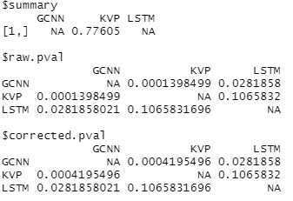
Test on Accuracy:
Iman Davenport's correction of Friedman's rank sum test
Corrected Friedman's chi-squared = 4.2961, df1 = 2, df2 = 238, p-value = 0.01469
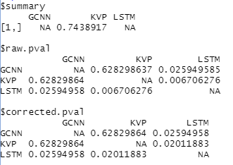
Tests for “complex datasets” (BPI11, EnvLog) (n=76 per model)
F1:
Iman Davenport's correction of Friedman's rank sum test
Corrected Friedman's chi-squared = 87.518, df1 = 2, df2 = 58, p-value < 2.2e-16
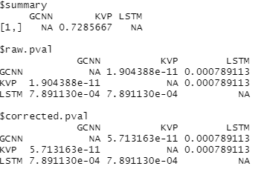
Accuracy:
Iman Davenport's correction of Friedman's rank sum test
Corrected Friedman's chi-squared = 43.702, df1 = 2, df2 = 58, p-value = 2.659e-12
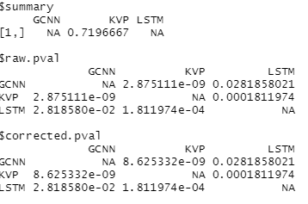
For 5.4:
BPI12O BPI12A
F1:
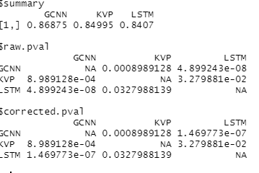
Acc:
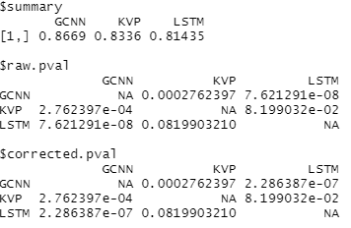
BPI12WComplete BPI12Complete:
F1
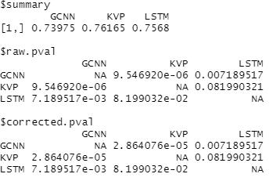
Acc
