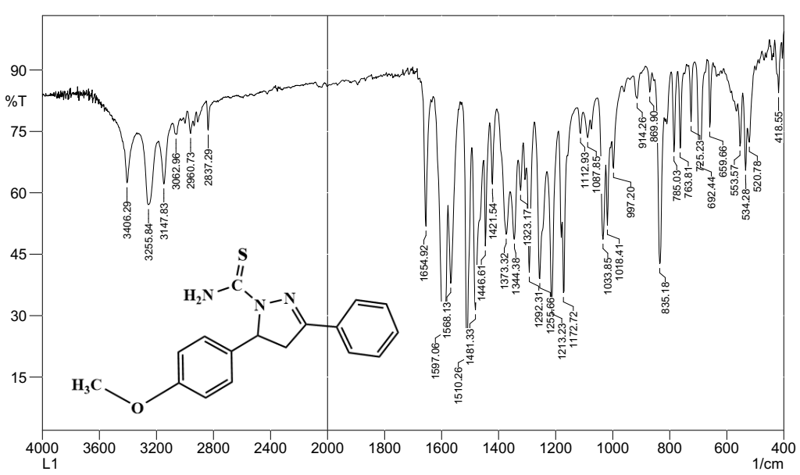
Figure S1: IR Spectrum 4,5-dihydro-5-(4-methoxyphenyl)-3-phenylpyr azole-1-carbothioamide (L) ligand

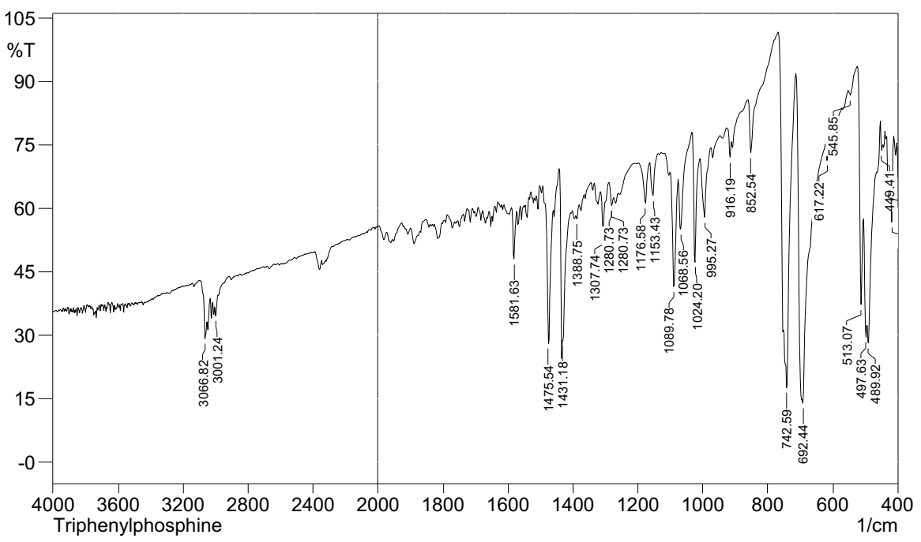
Figure S2: IR Spectrum of triphenylphosphine ligand.
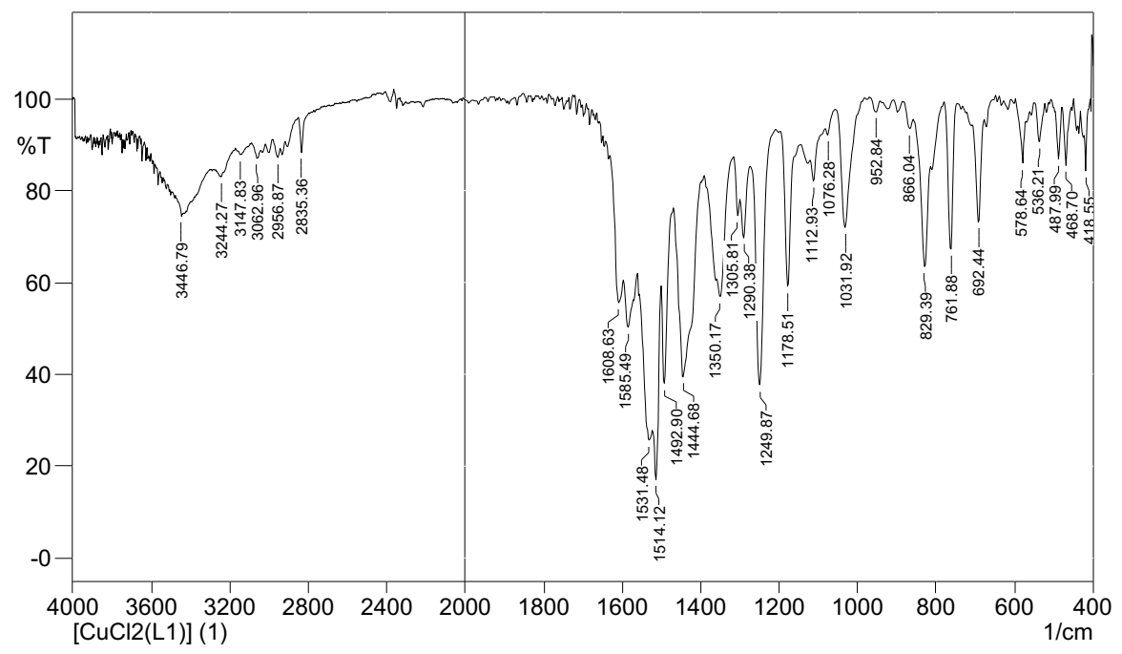
Figure S3: IR Spectrum of [CuCl₂(L)] 1
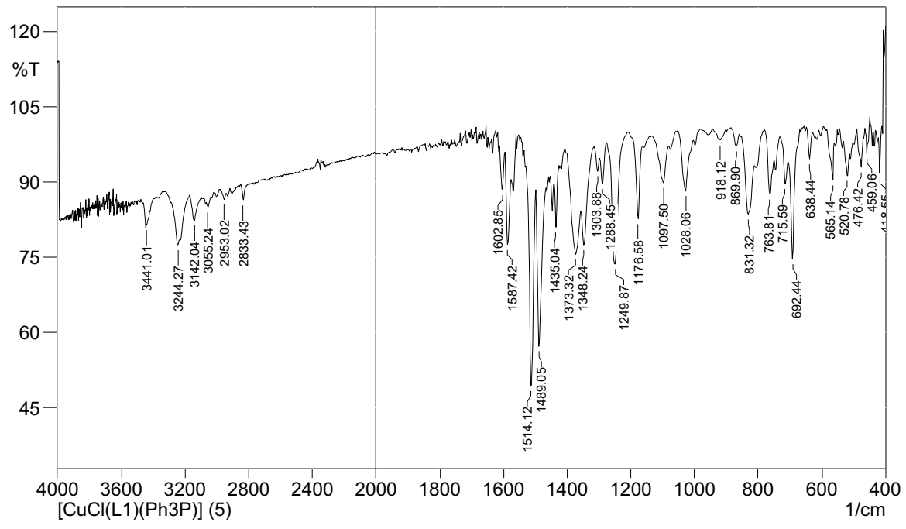
Figure S4: IR Spectrum of [CuCl(L)(Ph₃P)] 2
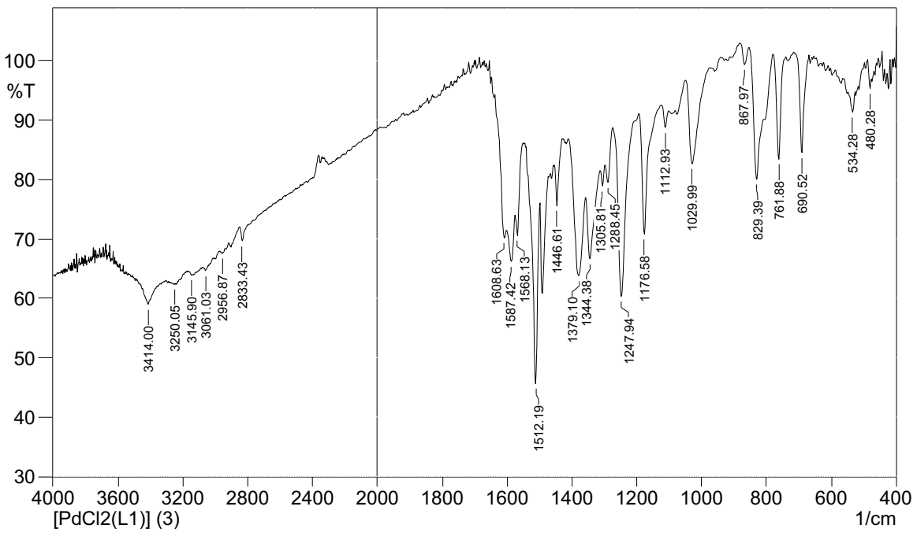
Figure S5: IR Spectrum of [PdCl₂(L)] 3

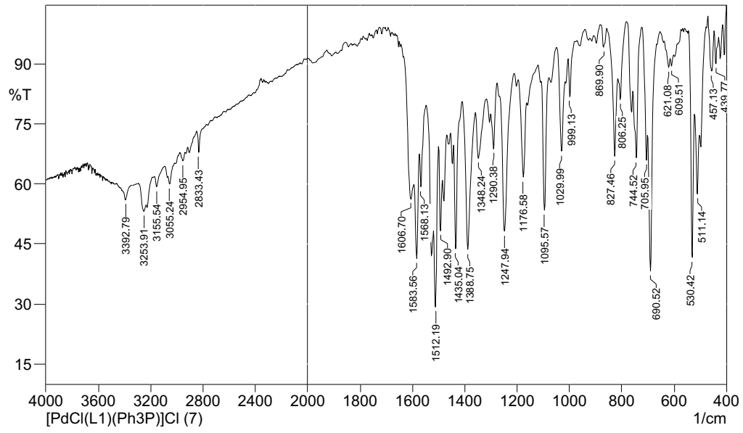
Figure S6: IR Spectrum of [PdCl(L)(Ph₃P)]Cl 4
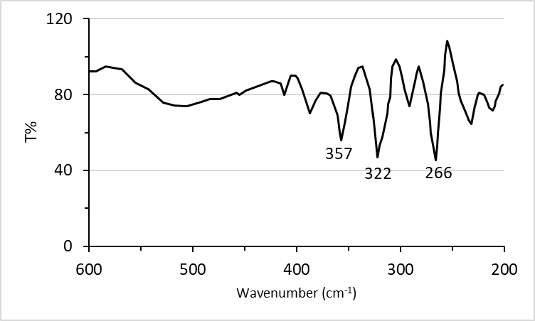
Figure S7: Far-IR spectrum of [CuCl₂(L)] 1

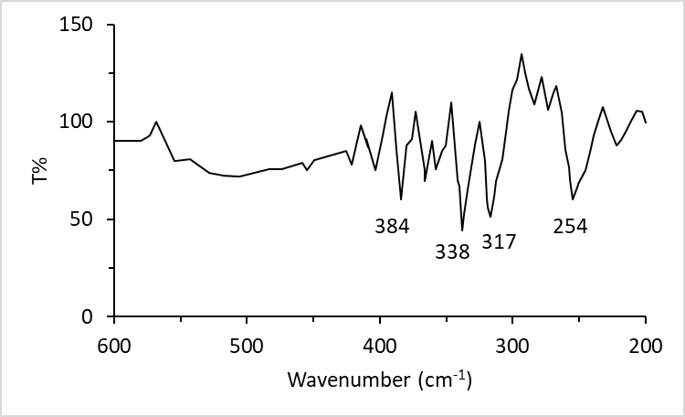
Figure S8: Far-IR spectrum of [CuCl(L)(Ph₃P)] 2
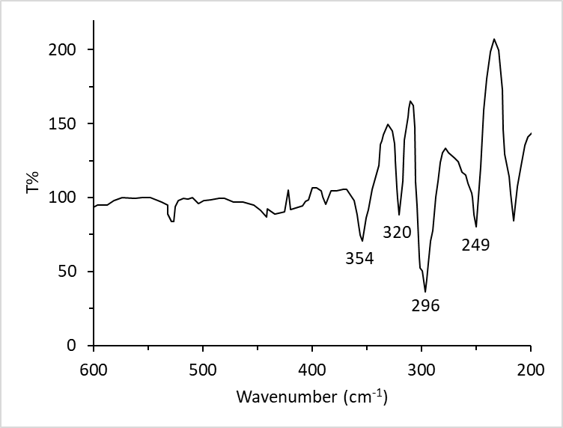
Figure S9: Far-IR spectrum of [PdCl₂(L)] 3
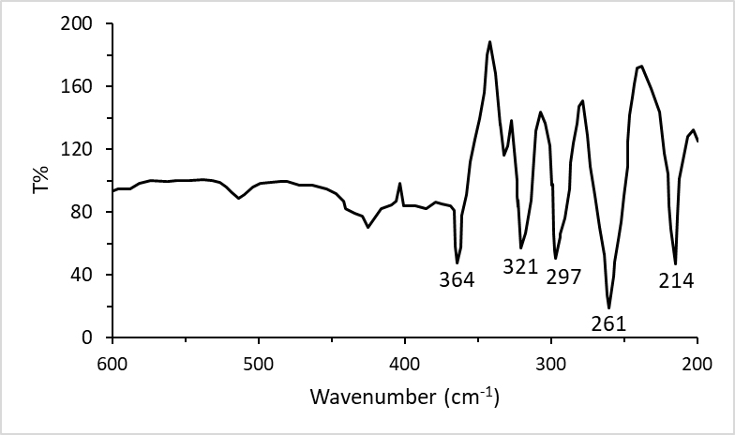
Figure S10: Far-IR spectrum of [PdCl(L)(Ph₃P)]Cl 4

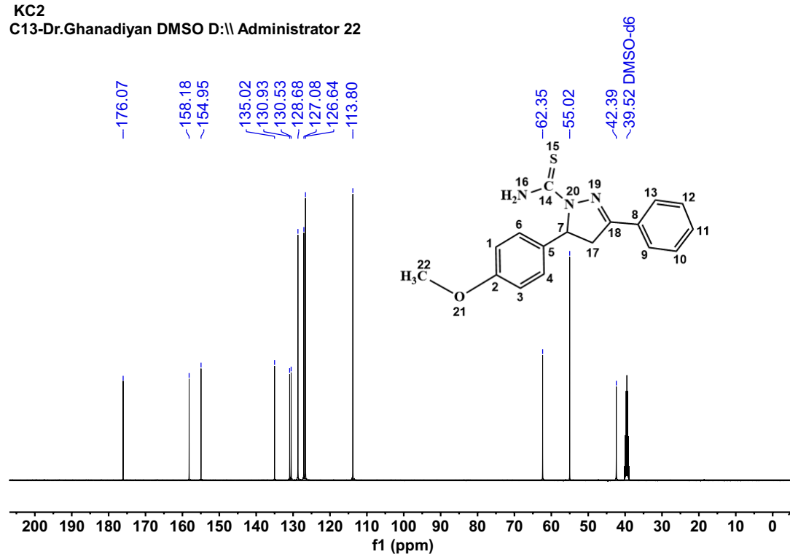
Figure S11: ¹³C-NMR spectrum of 4,5-dihydro-5-(4-methoxyphenyl)-3-phenylpyr azole-1-carbothioamide (L) ligand
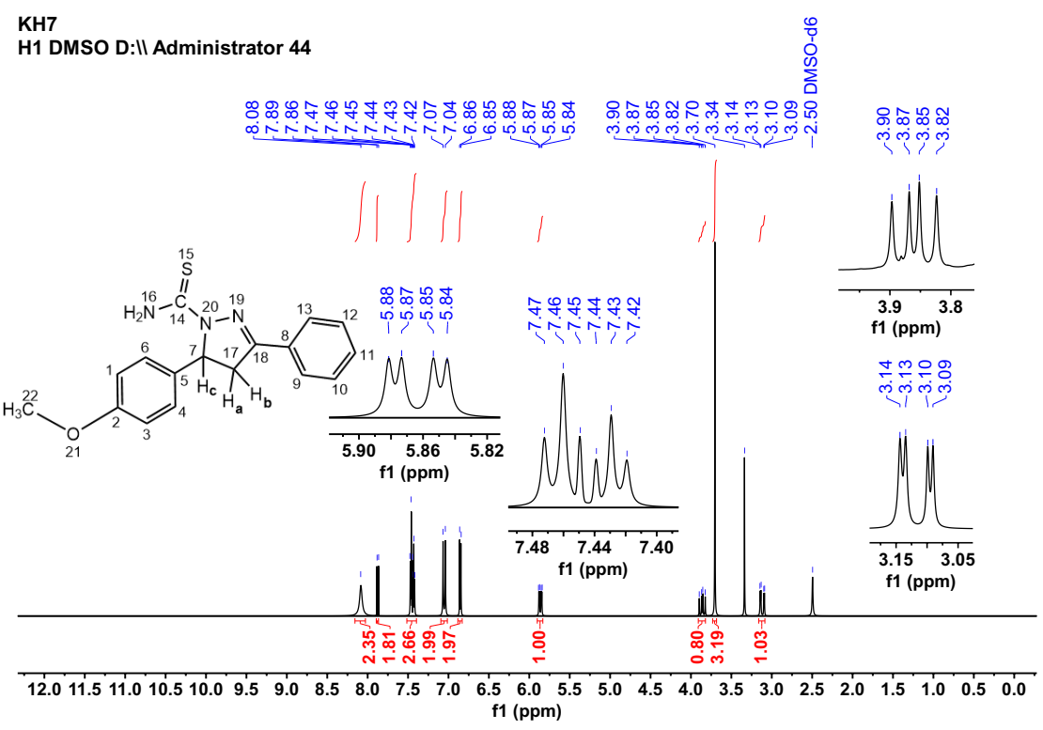
Figure S12: ¹H-NMR spectrum of 4,5-dihydro-5-(4-methoxyphenyl)-3-phenylpyr azole-1-carbothioamide (L) ligand
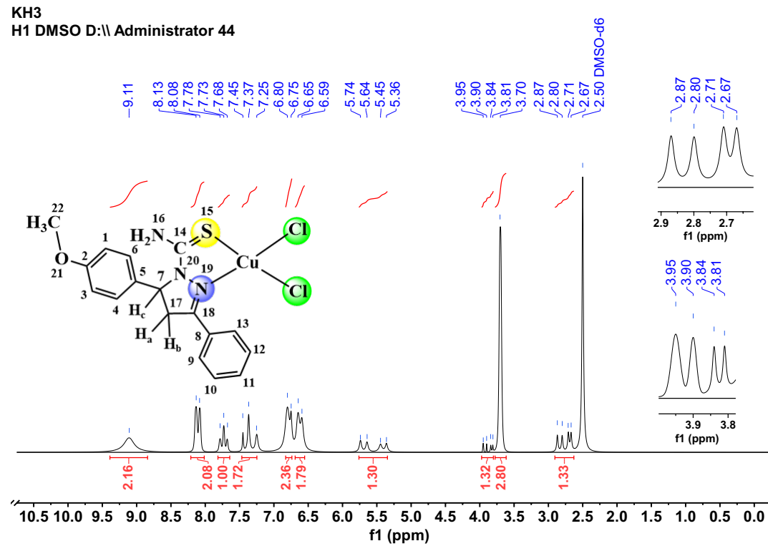
Figure S13: ¹H-NMR spectrum of [CuCl₂(L)] 1
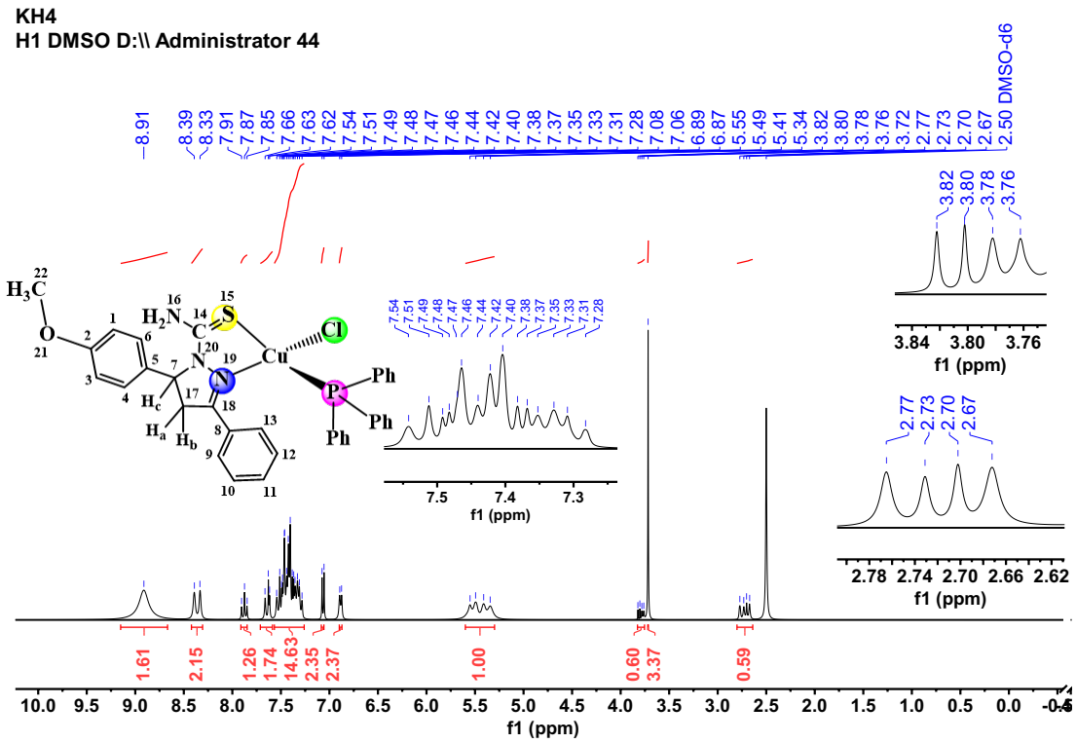
Figure S14: ¹H-NMR spectrum of [CuCl(L)(Ph₃P)] 2
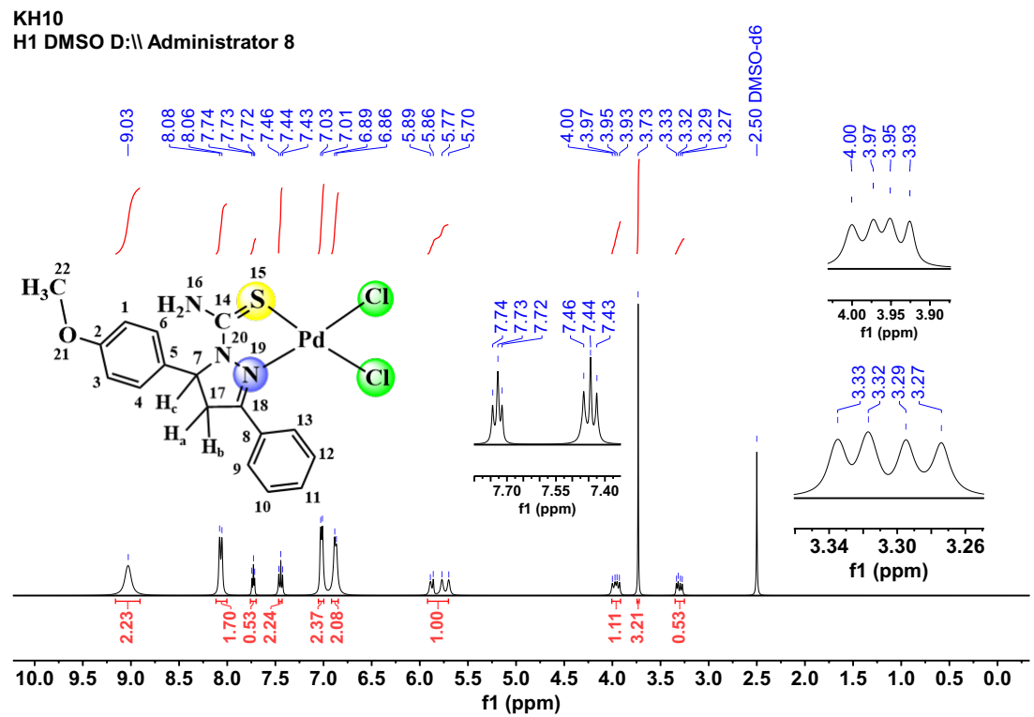
Figure S15: ¹H-NMR spectrum of [PdCl₂(L)] 3
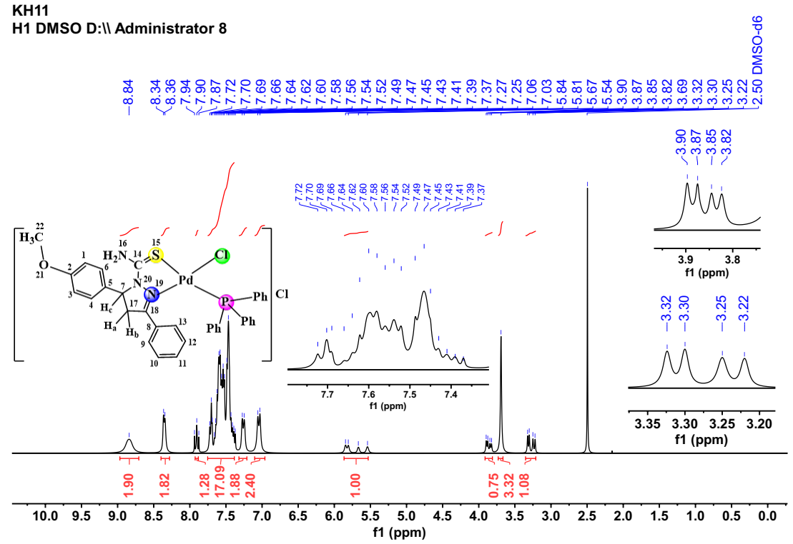
Figure S16: ¹H-NMR spectrum of [PdCl(L)(Ph₃P)]Cl 4
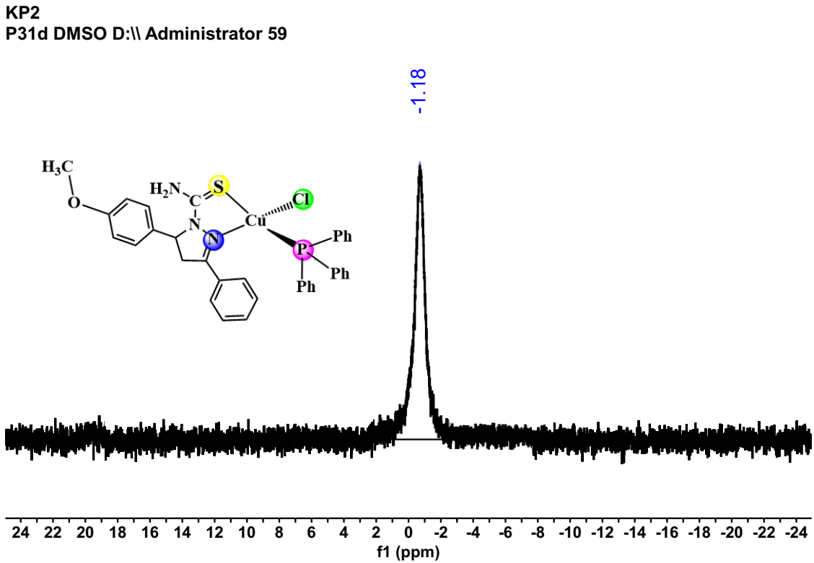

Figure S17: ³¹P-NMR spectrum of [CuCl(L)(Ph₃P] 2

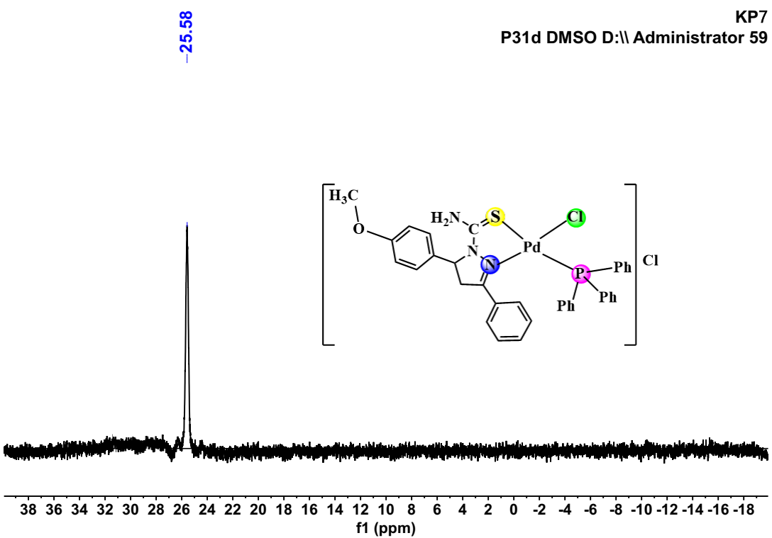
Figure S18: ³¹P-NMR spectrum of [PdCl(L)(Ph₃P)]Cl 4

